CHAPTER 6 STUDY GUIDE
Art Works & Artists You Should Know:
- The Four Horsemen by Albrecht Durer (1498) (woodcut)
- Stages of Making a Color Print by Kuniyoshi Utagawa (woodcut)
- Rime of the Ancient Mariner by Gustave Dore (wood engraving)
- Saint Anthony Tormented by Demons by Martin Schongauer (engraving)
- Gin Lane by William Hogarth (engraving)
- Christ with the Sick Around Him by Rembrandt van Rijn (etching)
- The Letter by Mary Cassatt (aquatint)
- Miss Loie Fuller by Henri de Toulouse-Lautrec (lithograph)
- Untitled (We Don’t Need Another Hero) by Barbara Kruger (silk screen)
- Wheatfield and Line of Trees by Edgar Degas (monotype)
a.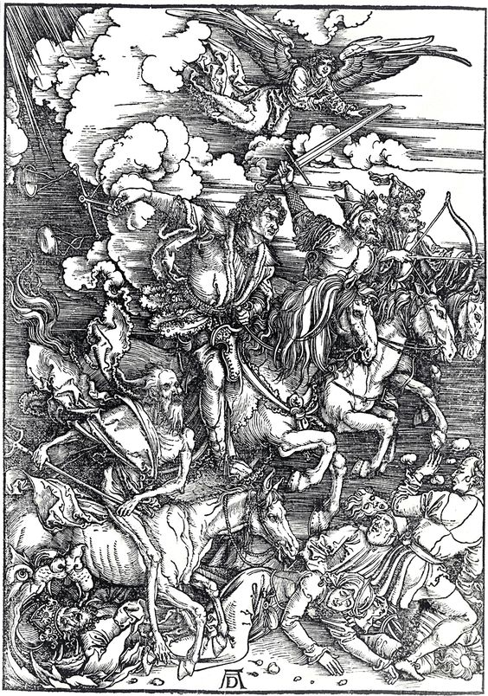b.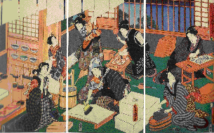c.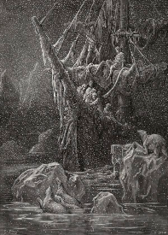d. 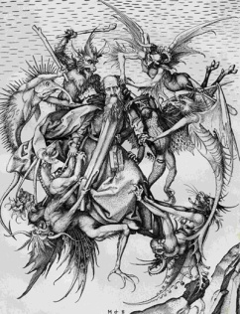
e.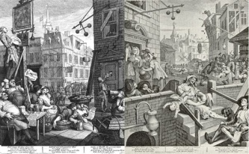f.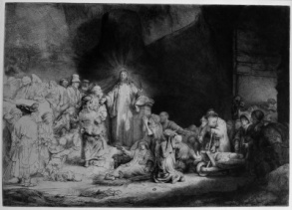g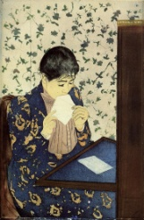h.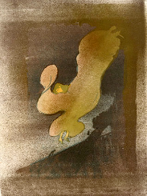i.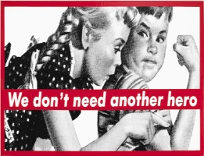
i. 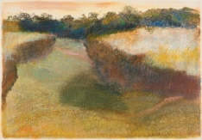
Vocabulary:
- Edition:
- Woodcut:
- Relief printmaking:
- Registration:
- Wood Engraving:
- Intaglio:
- Engraving:
- Etching:
- Ground:
- Aquatints:
- Lithograph:
- Silkscreen (or serigraphy):
- Appropriate:
- Monotype:
- Proof:
Questions You Should Be Able to Answer:
- What is the difference between an art print and a poster?
- Explain the Japanese wood cut process.
- What was William Hogarth trying to do with his prints?
- What was lithography first used for?
- What do you think about artists using appropriated images? Is it okay? Why or why not? (Give examples.)

