CHAPTER 4 & 5 STUDY GUIDE
Art Works & Artists You Should Know:
- Self Portrait 1933 by Kathe Kollwitz
- Three Studies of a Youth by Jean Antoine Watteau
- Six Pillows by Albrecht Durer
- Gone: An Historical Romance by Kara Walker
- The Seasons: Summer, 1985 Jasper Johns
- The Sistine Chapel by Michelangelo
- Christina’s World by Andrew Wyeth
- Snow Storm: Steam –Boat off a Harbour’s Mouth by J.M. Turner
- The Bay, 1963 by Helen Frankenthaler
- Prevalence of Ritual: Baptism by Romare Bearden
a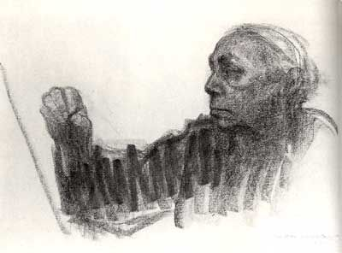.b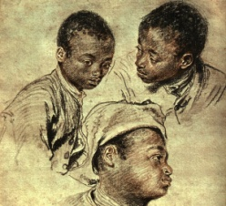c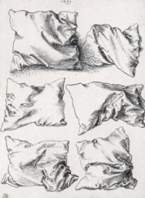.d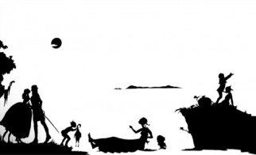.e.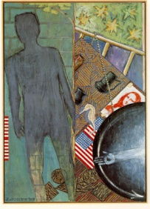
f.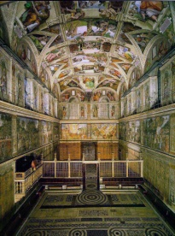g.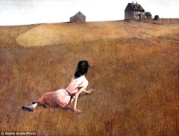h.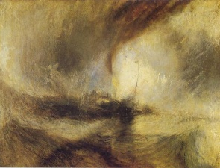i. 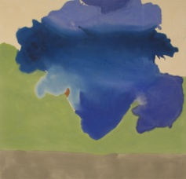 j.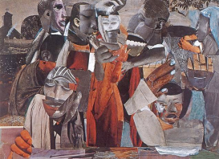
Vocabulary:
- Metalpoint:
- Graphite:
- Charcoal:
- Fixative:
- Chalk and Pastel:
- Ink (pen and brush):
- Cross hatch:
- Ink wash:
- Pigment:
- Binder:
- Ground:
- Fresco:
- Tempura (egg)
- Oil paint:
- Glazes:
- Under painting:
- Impasto:
- Gouache:
- Acrylic:
- Collage:
Questions You Should Be Able to Answer:
- What is the difference between metalpoint and charcoal?
- Tell me some of the ways artists have used ink over the years?
- Describe the process of creating an encaustic painting?
- How is oil paint different and similar to acrylic paint?
- What are some new “painting” materials artists are experimenting with today?

