CHAPTER 3 STUDY GUIDE
Art Works & Artists You Should Know:
- Fur Traders Descending the Missouri by George Caleb Bingham
- Untitled, 2003 by Tara Donovan
- Two Calla Lilies on Pink by Georgia O’Keeffe
- Walking Man II by Alberto Giacometti
- Under the Table by Robert Therrien
- Echo of a Scream by David Siquieros
- Maple Leave at the Tekona Shrine by Utagawa Hiroshige
- View of an Ideal City by Piero della Francesca
- Violin and Palette by Georges Braque
- Waterfall by M. C. Escher
a.b.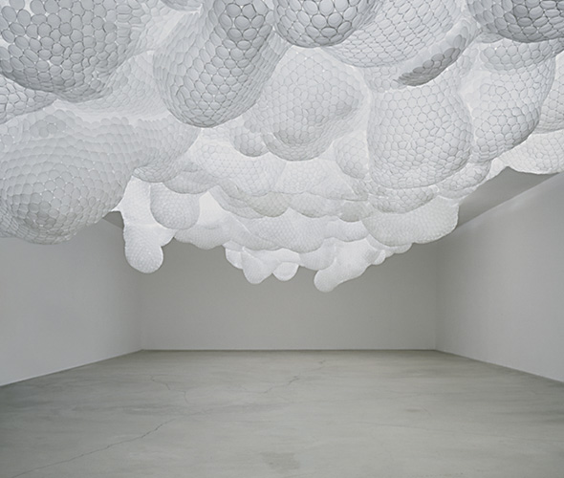c.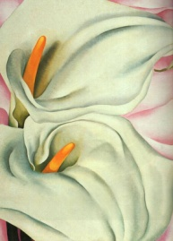.d.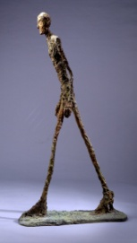e. 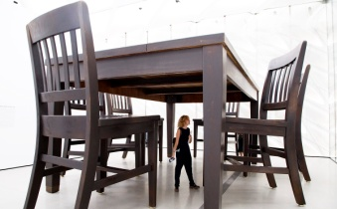
f.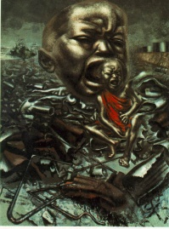g.h.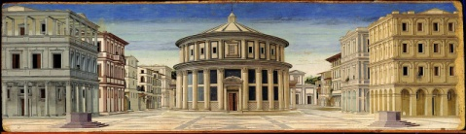i.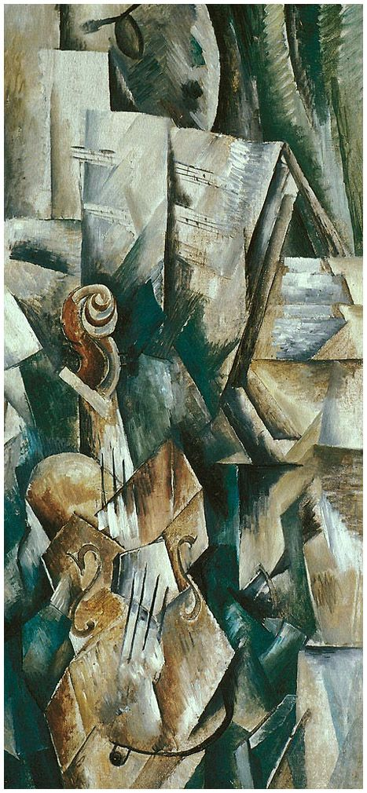j. 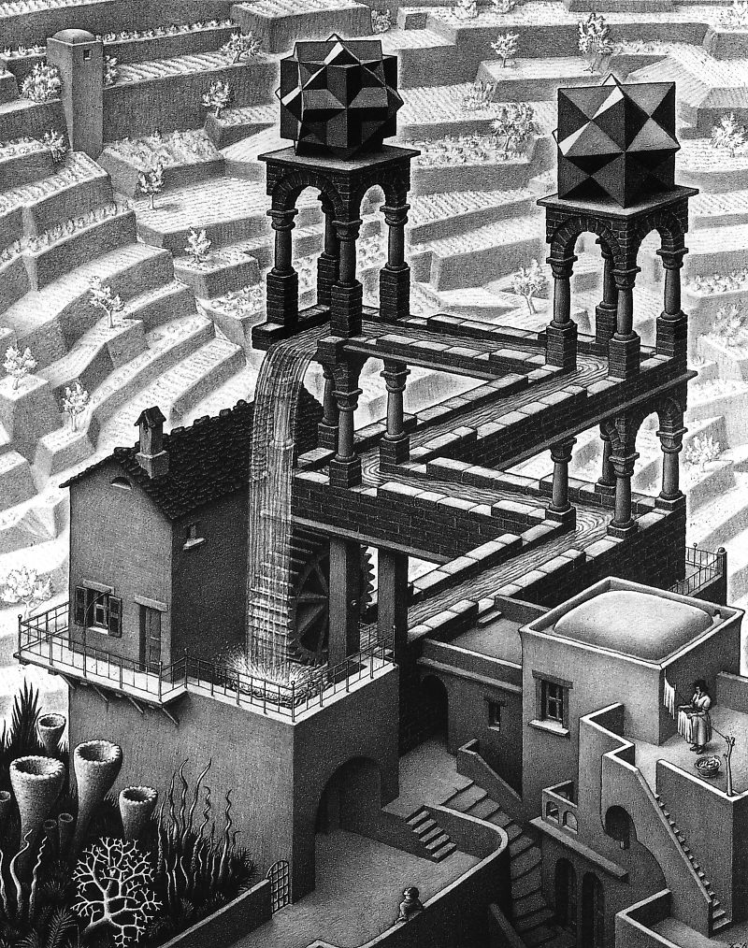
Vocabulary:
- Placement (or Composition):
- Positive form (or space):
- Negative form (or space):
- Visual weight:
- Symmetrical balance:
- Radial Balance
- Mandalas:
- Asymmetrical balance
- Emphasis
- Unity/Variety
- Rhythm:
- Proportion:
- Scale:
- Atmospheric Perspective:
- Linear Perspective:
- Vanishing Point:
- One-Point Perspective:
- Horizon Line:
- Foreshortening:
- Cubism:
Questions You Should Be Able to Answer:
- What are the 6 “Principles of Design” we talked about (look for orange words in the Power Point)?
- How do artists create “rhythm” in an art work?
- What were the cubists trying to do with space in their paintings?
- How do artists show distance or perspective in an artwork?
- If the elements of art are like atoms, what can you compare the principles of design to?

