CHAPTER 19 & 20 STUDY GUIDE
Art Works & Artists You Should Know:
- Blue Mountain by Vasily Kandinsky
- Broadway Boogie Woogie by Piet Mondrian
- Door to River by Willem de Kooning
- Number 1 by Jackson Pollock
- Campbell’s Soup 1: Tomato by Andy Warhol
- Spoonbridge and Cherry by Claus Oldenburg
- Central Savings by Richard Estes
- Still Life with red Mat by Ralph Goings
- Mr Dob Panda Family by Takashi Murakami
- Untitled (Portrait of Ross in L.A.) by Felix Gonzalez-Torres
a. 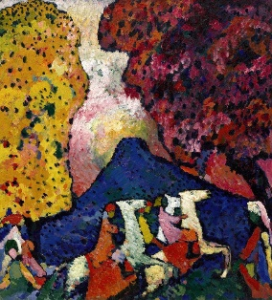 b.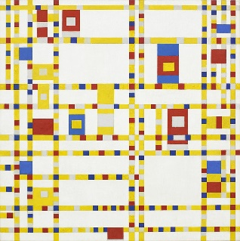c.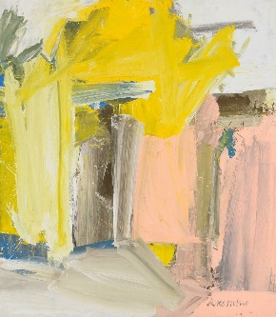d. 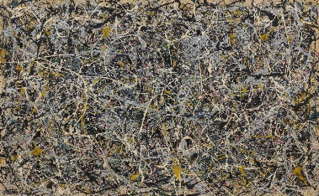
e.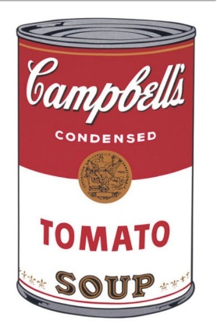f.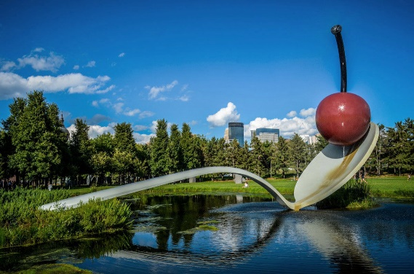g.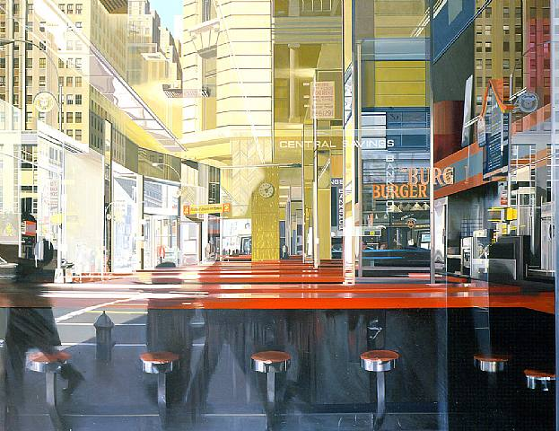h. 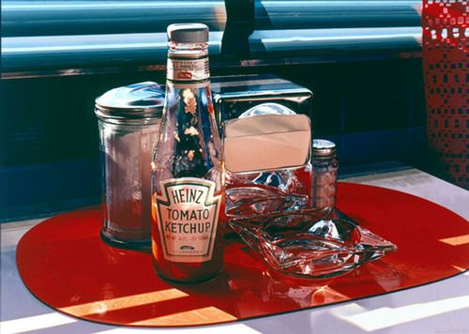 i. 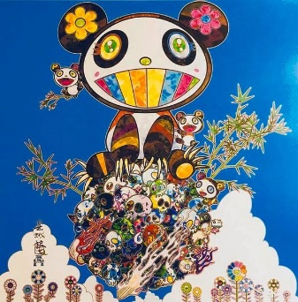 j.

Vocabulary:
- Non-Representational:
- Abstract Expressionism:
- Pop Art:
- Photorealism (or Superrealism):
- Earth Art:
- Futurism:
- Conceptual art:
Questions You Should Be Able to Answer:
- What was Vasily Kandinsky very sensitive to?

- What sculptor did we look at who created “super realist” figures?
- What kind of art does Andy Goldsworthy create?

