CHAPTER 18 STUDY GUIDE
Art Works & Artists You Should Know:
- Landscape of the Midi by Andre Derain
- The Old Guitarist by Pablo Picasso
- Three Musicians by Pablo Picasso
- Unique Forms of Continuity in Space by Umberto Boccioni
- Fountain by Marcel Duchamp
- Persistence of Memory by Salvador Dali
- Golconda by Rene Magritte
a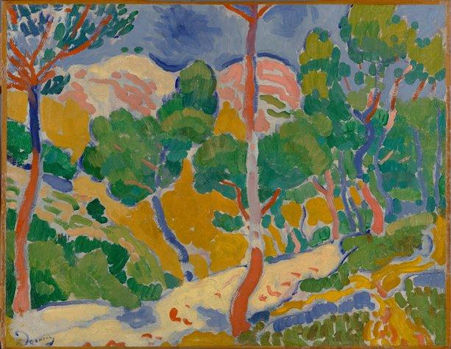.b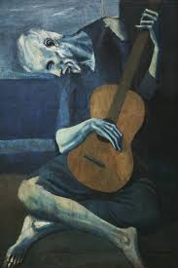.c.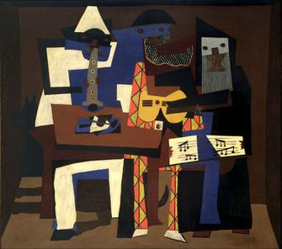d. 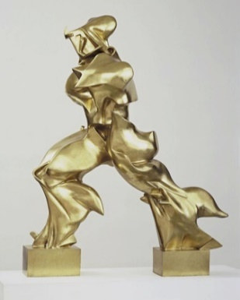
e. 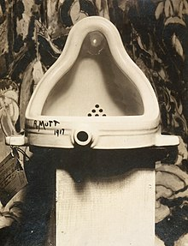 f.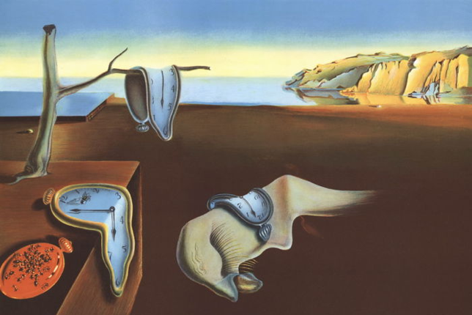g.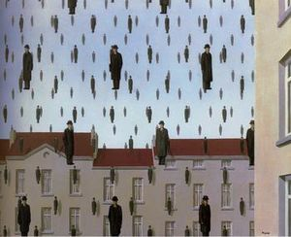
Vocabulary:
- Fauvism:
- Cubism:
- Blue Period (Cubism):
- Analitical Cubism:
- Synthetic Cubism:
- Manifesto of Futurism:
- Futurism:
- Dada:
- Surrealism:

Questions You Should Be Able to Answer:
- What was going on at the end of the 19th Century?

- What was the Eifel Tower a symbol of?
- What does “fauve” mean in French?

- How does Tomasso Marinetti affect the art world in 1909?
- What does the term Dada mean?

- How does World War I affect the art world?

- What does the Dada manifesto call for?

- How did the studies of psychiatrist Sigmund Freud affect the art world?

