CHAPTER 16: The Battle of the “Isms”
Neoclassicism, Romanticism and Realism

1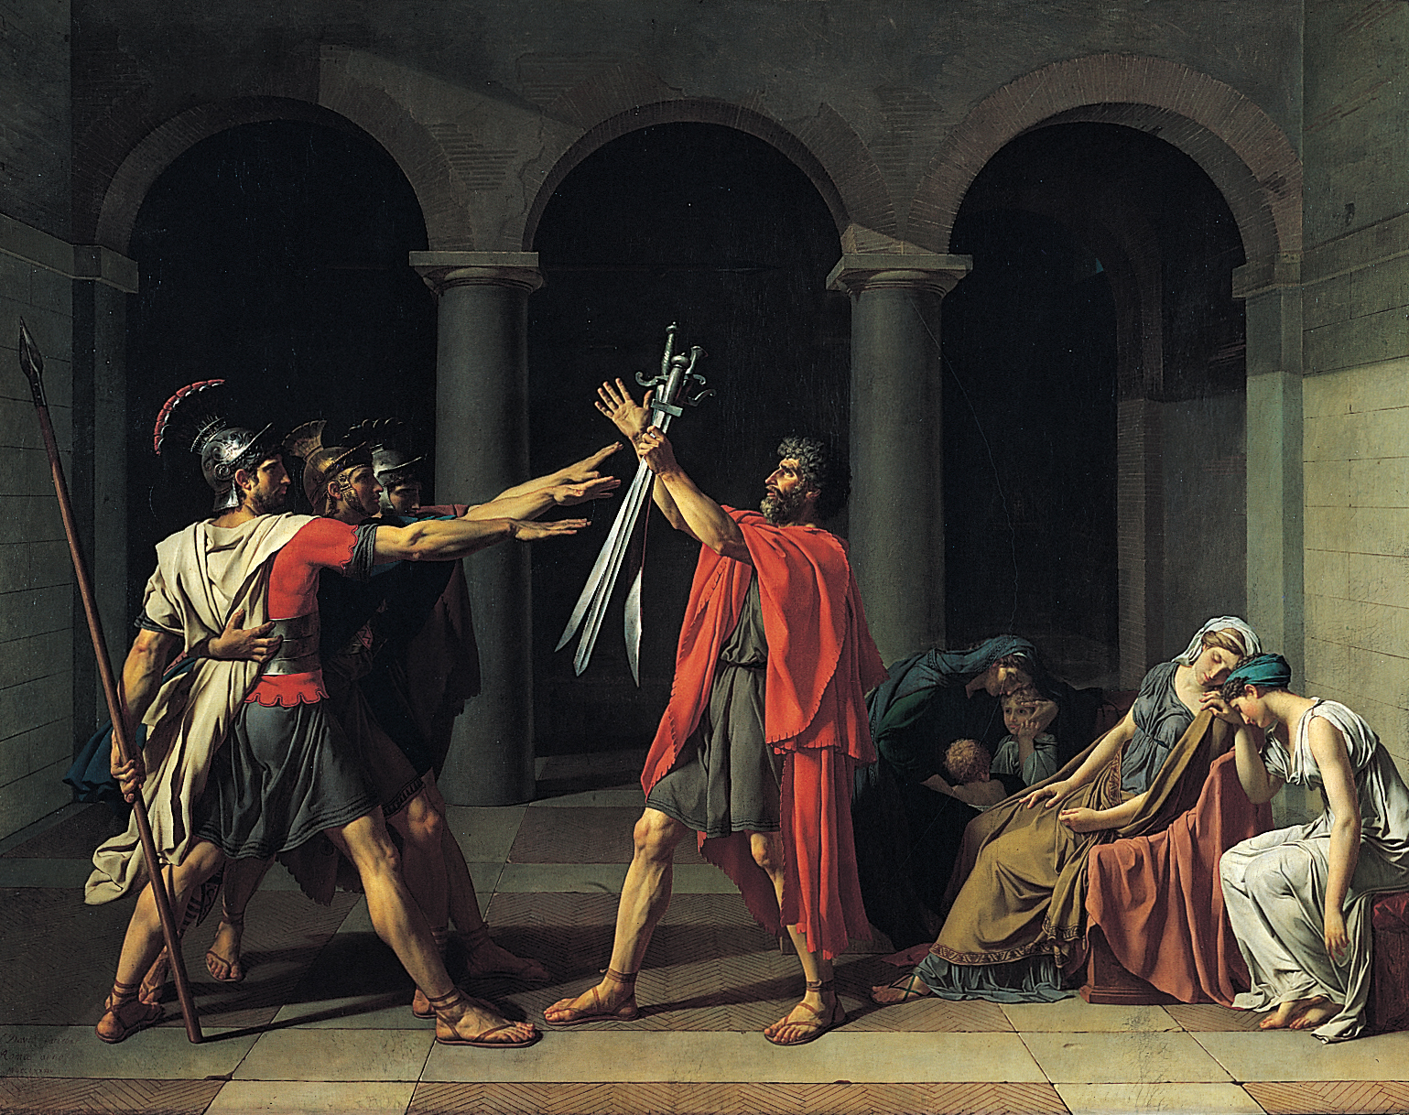 2.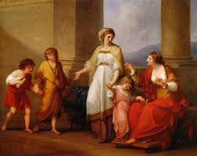3.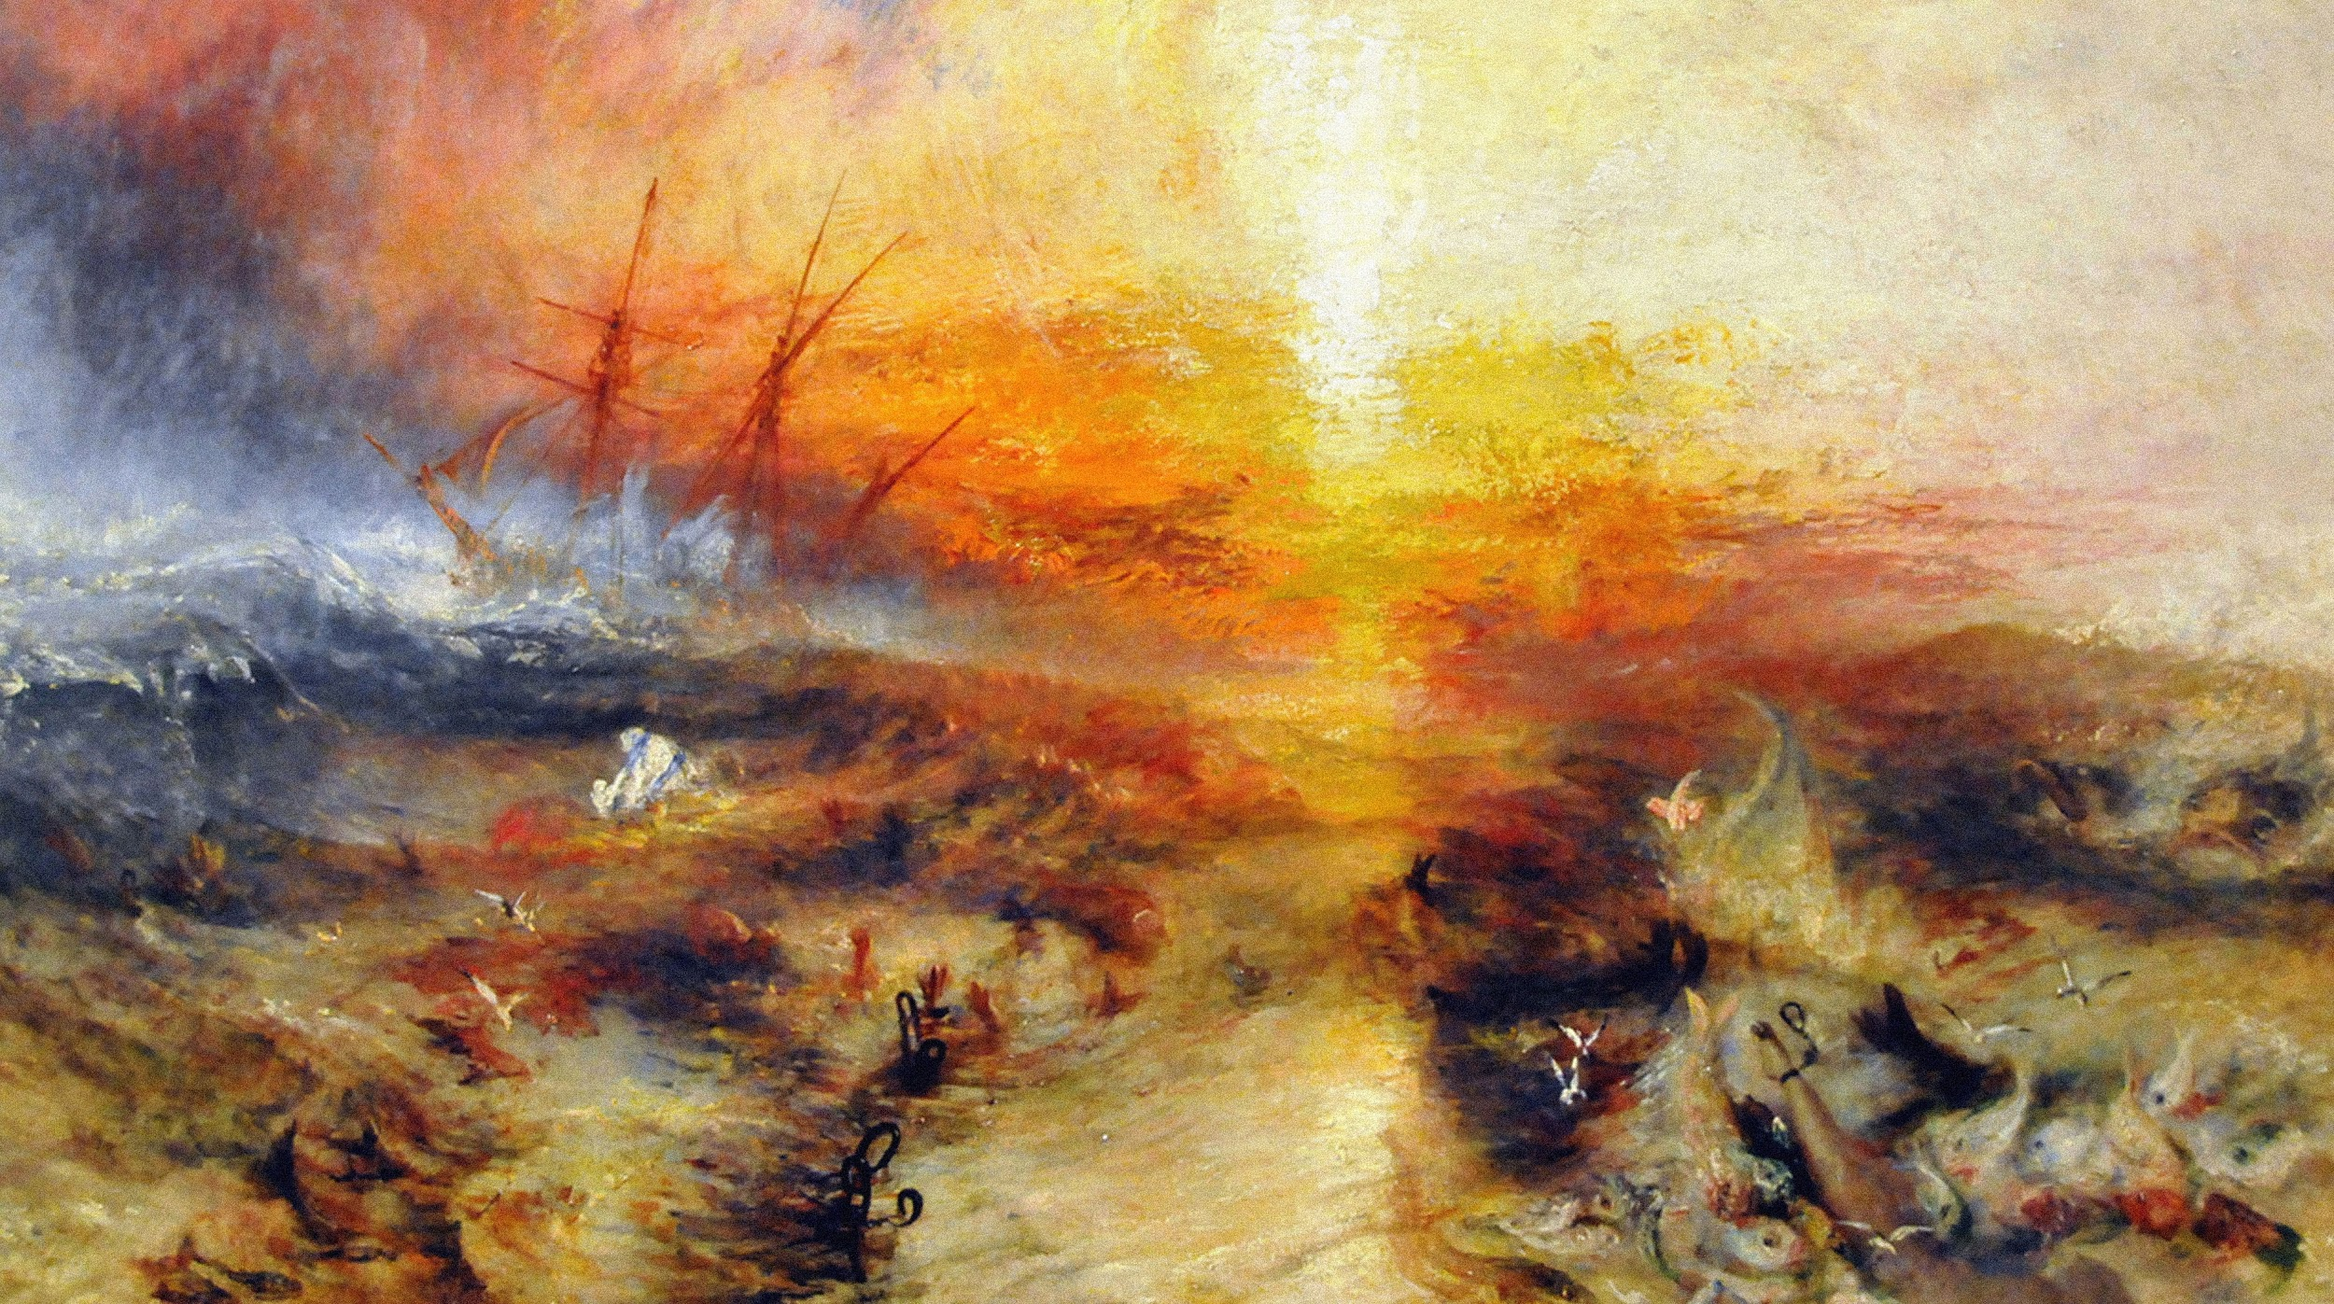
4.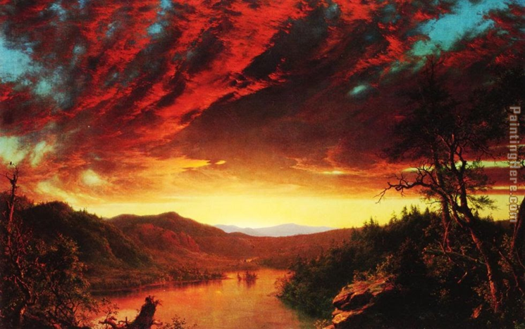5.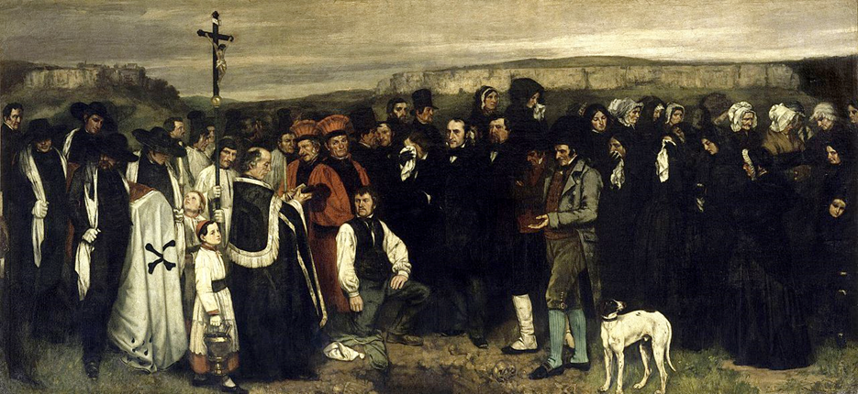6.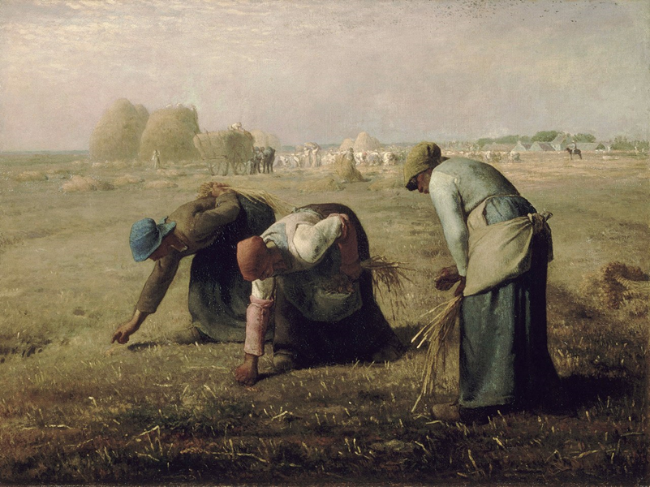

- Oath of the Horatii by Jacques-Louis David
- Cornelia Pointing to Her Treasures by Angelica Kauffman
- Slave Ship by JMW Turner
- Twilight in the Wilderness by Frederic Edwin Church
- The Burial at Ornans by Gustave Courbet
- The Gleaners by Jean Francois Millet

Vocabulary

- Age of Enlightenment (or Age of Reason):
- Neoclassicism:
- Romanticism:
- Realism:
- Hudson river school:

Things to Know
- When did the “Age of Enlightenment” take place?

2. How was Romanticism different from Neoclassicism?

3. What were the Realists trying represent with their art?

