CHAPTER 13 STUDY GUIDE
Art Works & Artists You Should Know:
- Constantine the Great
- Theodora and Attendants, mosaic
- Saint Mathew from the book of Lindisfarne
- The Great Mosque at Cordoba Spain
- Hagia Sophia Mosque, Turkey
- Seated Buddha Preaching the First Sermon, India
- Shiva Nataraja, Lord of the Dance, (Hinduism)
- Last Judgment BY Gislebertus
- Interior of Sainte Chapelle, Paris
- St. Francis Preaching to the Birds by Bonaventura Berlinghieri
a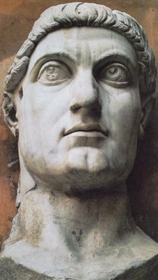.b.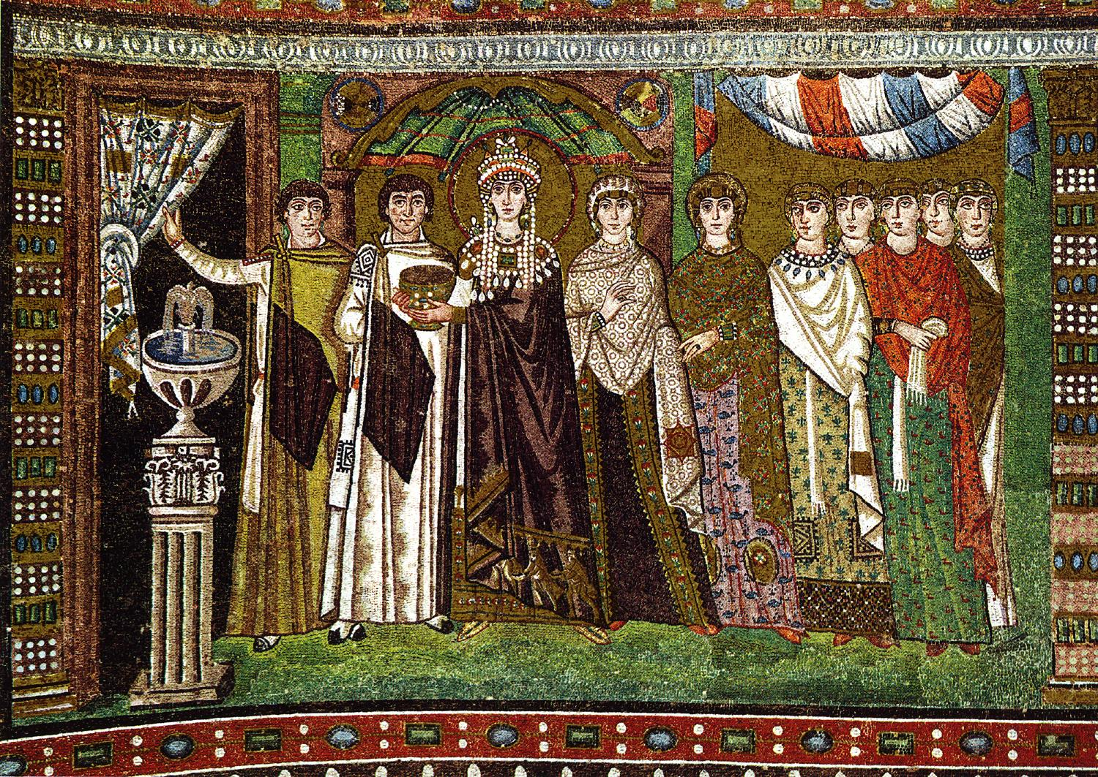c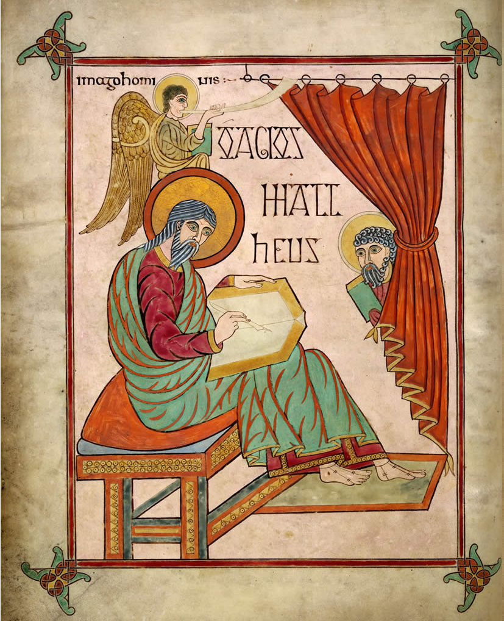.d.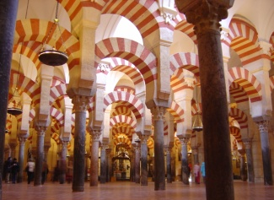e.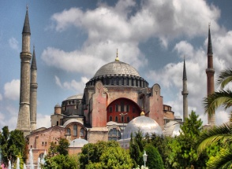 f.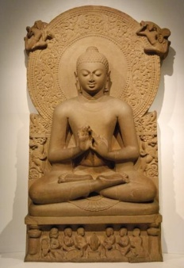g.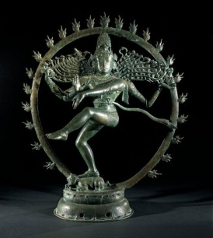h. 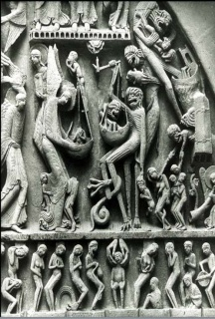i. 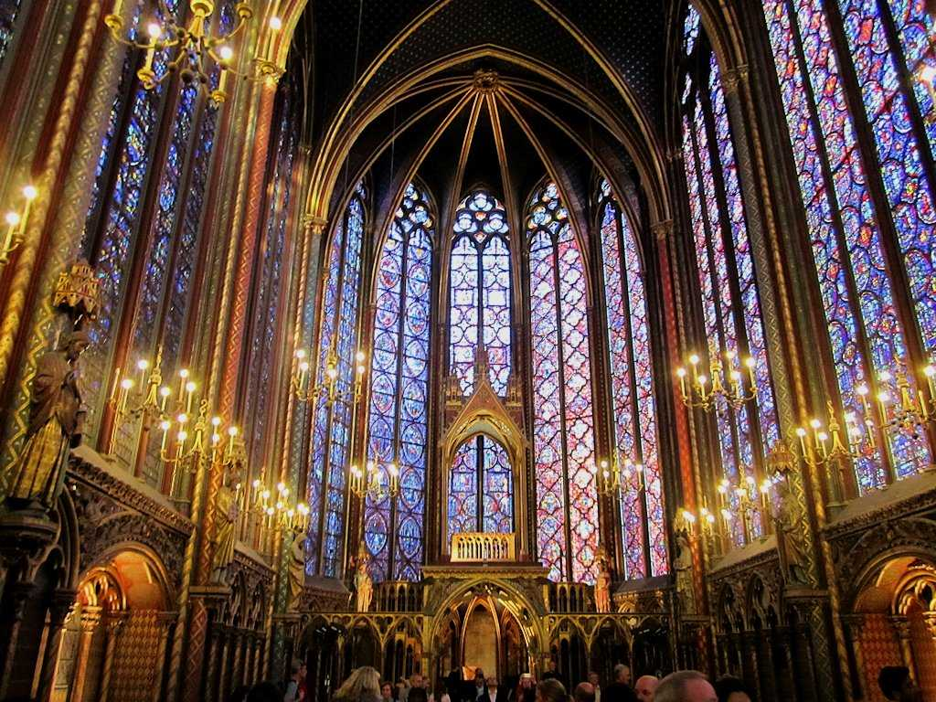 j. 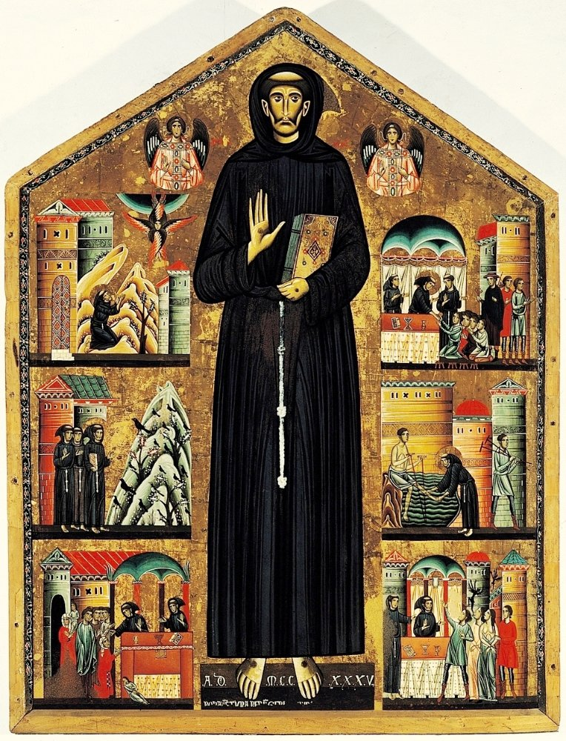
Vocabulary:
- Byzantine:
- Nomadic:
- Illumination:
- Qur’an:
- Mihrab:
- Romanesque architecture:
- Nave:
- Transept:
- Gothic architecture:
Questions You Should Be Able to Answer:
- How did Constantine affect the art world?
- Describe what Byzantine art looks like and give an example.
- How did the Islamic faith influence the art that they created?
- Where did Buddhism begin and what countries did it spread to?
- What are some thing Hindus believe?
- What was a common theme in art around 1000 AD?
- How was Romanesque style different from the Ancient Greeks and Romans?
- How does the Romanesque attitude about the nude human figure differ from ancient Greeks and Romans?

- How is Gothic architecture different from Romanesque architecture?
- What factors contributed to the development and popularity of the stained glass window?

- Describe the similarities between Medieval Italian art and Byzantine art.

