CHAPTER 12 STUDY GUIDE
Art Works & Artists You Should Know:
- The Great Sphinx, (Egypt)
- Queen Nefertiti
- Tutankhamen the second coffin
- Temple of Ramses II
- The Terra-Cotta Army, (China)
- Three Goddesses from the Parthenon
- The Discus Thrower, (Roman copy)
- Winged Victory (Hellenistic Greece)
- Lacoon
- The Colosseum, Rome
a.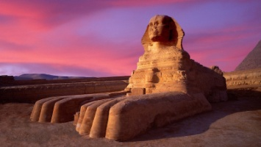b.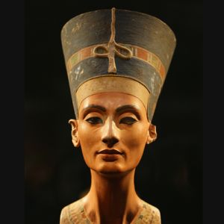c.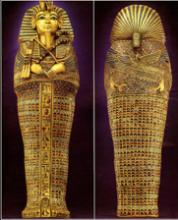d.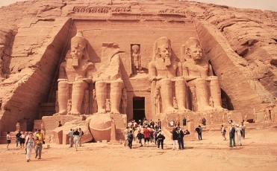e.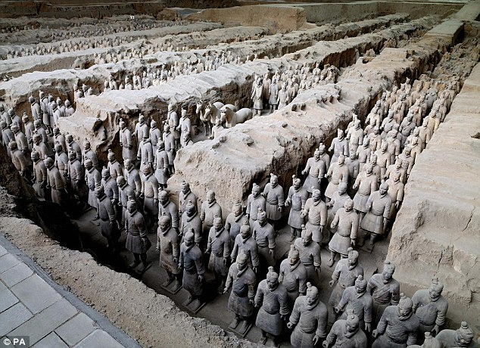f.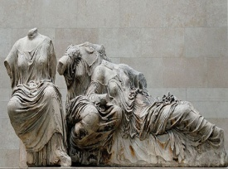g.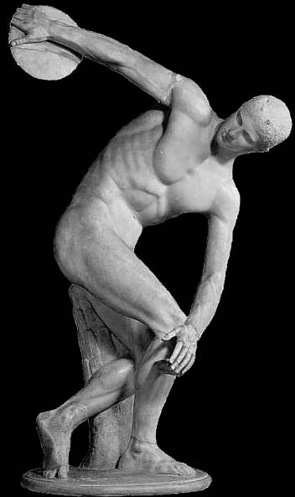h.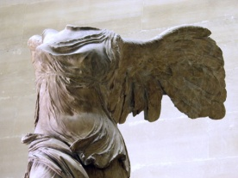i.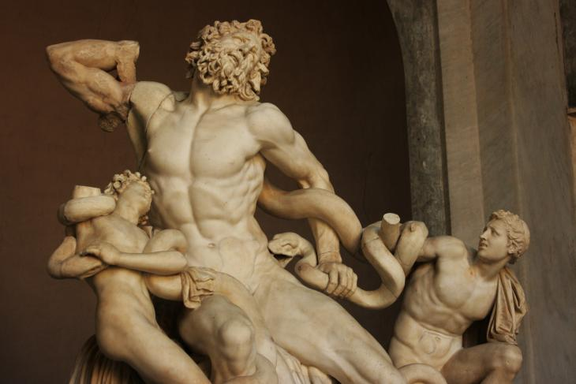j. 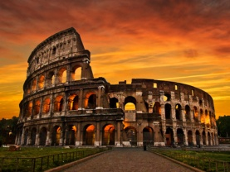

Questions You Should Be Able to Answer:
- List 3 interesting facts about The Great Sphinx.
- What is Queen Nefertiti remembered for?
- Why is Tutankhamen remembered more than other Pharohs?
- What is the difference between Classical Greek and Hellenistic Greek sculpture?
- Give an example of a Greek Statue and a Roman Statue.
- Why were Romans so influenced by other cultures especially the Greeks?
- List 3 interesting facts about the Colosseum.
- What is a mosaic?

