CHAPTER 10 STUDY GUIDE
Art Works & Artists You Should Know:
- The Kaufman House by Frank Lloyd Wright
- Dome of the Rock in Jerusalem
- Mesa Verda National Park
- Borobudur, Java, Indonesia
- Angkor Wat, Cambodia
- The Parthenon
- Arc de Triumph Paris, France
- Eiffel Tower, Paris, France
- Guggenheim Museum of Art, Bilbao, Spain
- St. Peter’s Basilica, Rome, Italy
a.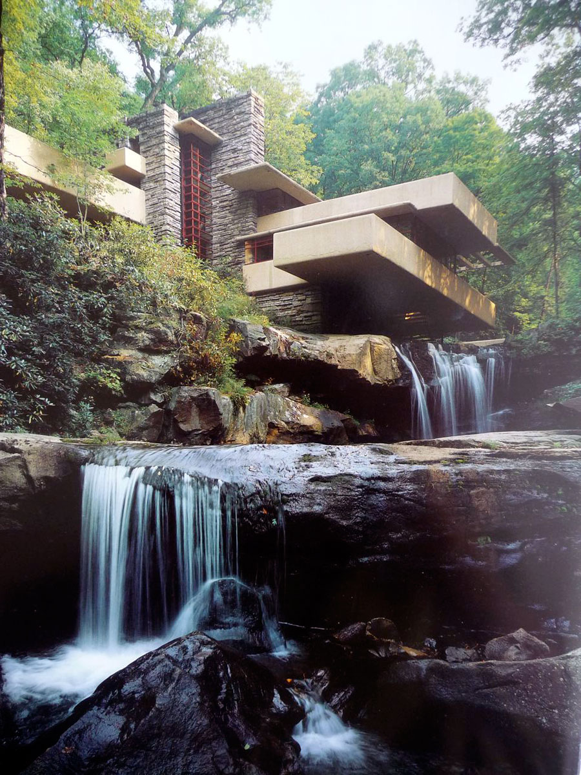b.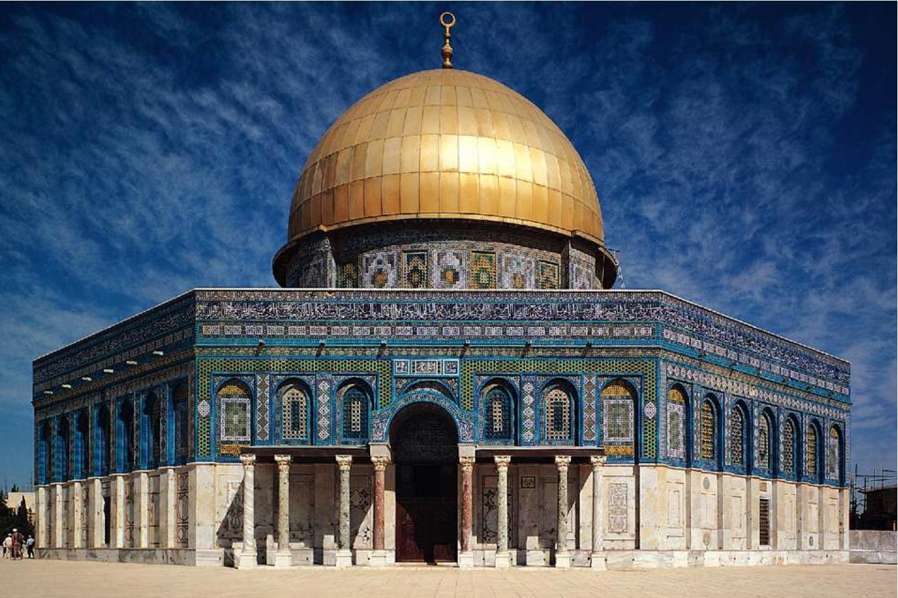c.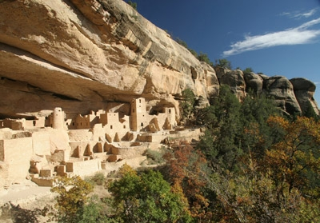d.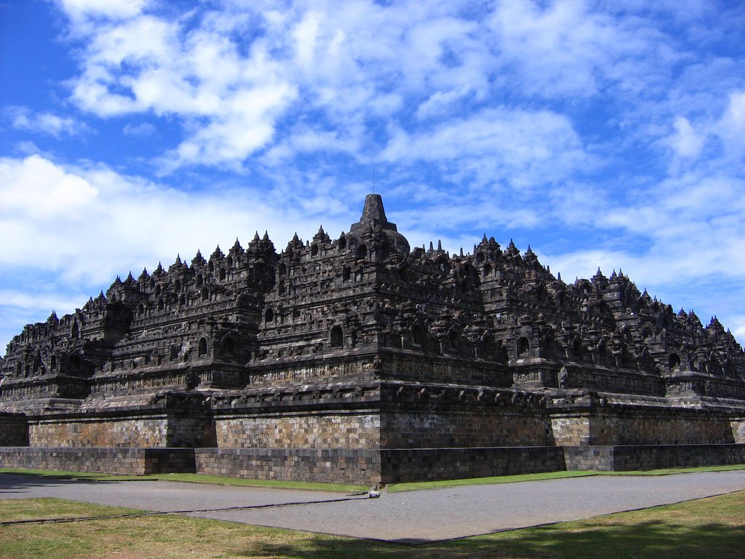e.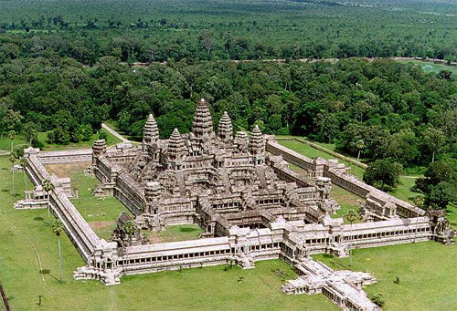 f.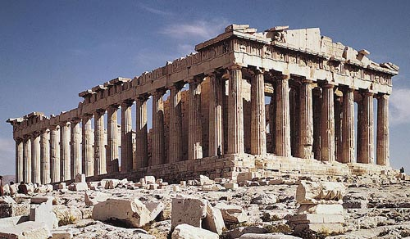g.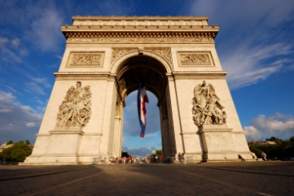h.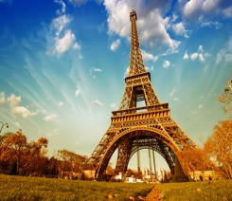i.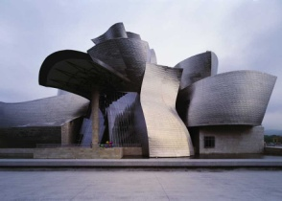j. 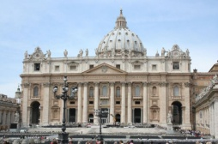
Vocabulary:
- Functional
- Vernacular Architecture:
- Capitals:
- Volutes:
- Doric:
- Ionic:
- Corinthian:
- Adobe:
- Post and Lintel:
- Barrel Vault:
- Groin Vault:
- Pointed Arch:
- Flying Buttress:
- Piazza:
- Ferroconcrete:
Questions You Should Be Able to Answer:
- Do you consider all buildings works of “art”? Why or why not?
- What time and cultural influences influenced this school’s architecture? Explain.
- What special “artistic” skills do architects need?
- What is the most impressive examples of architecture have you seen in real life? Explain why it was impressive.

- What do you think the architecture of the future will look like? Why?

