CHAPTER 1 STUDY GUIDE
Art Works You Should Know:
- “Mona Lisa” Leonardo da Vinci
- “Phoenix Hall” Byodo-in Temple in Uji Japan
- “Rose Window” Notre Dame Cathedral, Paris, France
- “Henry VIII” Hans Holbein the Younger
- “The Liberation of Aunt Jemima” Betye Saar
- “The Vietnam Memorial” Maya Lin
- “Clearing Winter Storm” Ansel Adams
- “The Gates” Cristo and Jeanne-Claude
- “The Little Deer” Frieda Kahlo
- “I and the Village” Marc Chagall
a.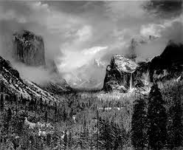b.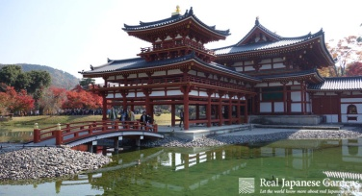c.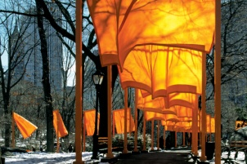d.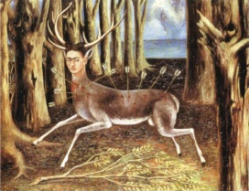e.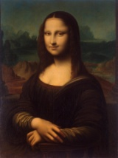 f. 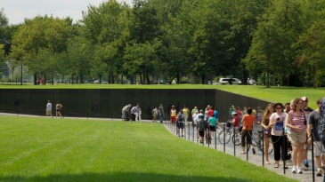 g.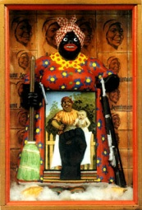 h.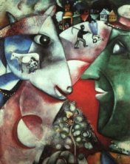 i.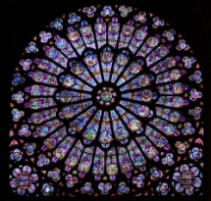 j.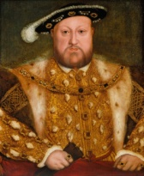
Vocabulary:
- Sfumato Light:
- Tribal Art:
- Found Object Art:
- Installation Art:
- Fine Art:
- Applied Art:
- Folk Art:
- Industrial Design:
- Graphic Design:
- Impressionism:
Questions You Should Be Able to Answer:
- How is looking at art different from looking at other things?

- How is “seeing” today different from primitive societies?

- Why do you feel the Mona Lisa is so famous? (cite evidence)

- Give an example of a faith-based art work?

- Give an example of prehistoric art?

- Give an example of an art work meant to shock and change our beliefs?

- Explain the controversy over the Vietnam Memorial.

- How was the art work “The Gates” created?

- Give an example of an art work inspired by a memory?

- What can we do to understand art better?

