Date: Sept. 18, 2020
In your journal record the following:
SCULPTURE ENTRY #9:
ART THINK: How good are you at reading facial expressions, guess the emotion shown on each face: 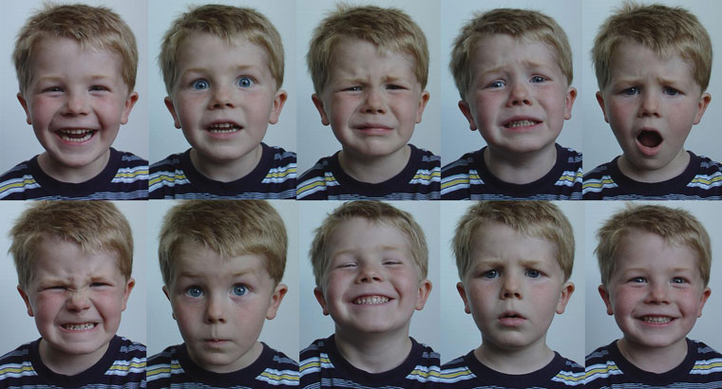
Announcements/Reminders:
- Turn in journal today if you didn’t last time!
Today’s Objective:
- Video clip: sculpting eyes
- Keep working on Green Man

