Date: Sept 21, 2016
In your journal record the following:
SCULPTURE ENTRY #9:
ART THINK: Review question: How do you clean up after working with clay?
Announcements/Reminders:
- Home work check TODAY!
- Green Man is due September 29th.
Today’s Objective:
- Review clay rules & clean up.
- Demo beginning Green Man
- Work on Green Man – “blocking in” the plans of the face.
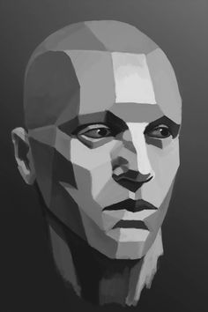
Homework:
Get caught up if you are behind.

