Date: February 14, 2020
In your journal record the following:
SCULPTURE ENTRY #9:
ART THINK: How did your skull turn out? What worked well? What would you change if you did it again? What did you learn?
Announcements/Reminders:
- Journal check TODAY!
Today’s Objective:
- Watch clip
- Get started on Green Man

- 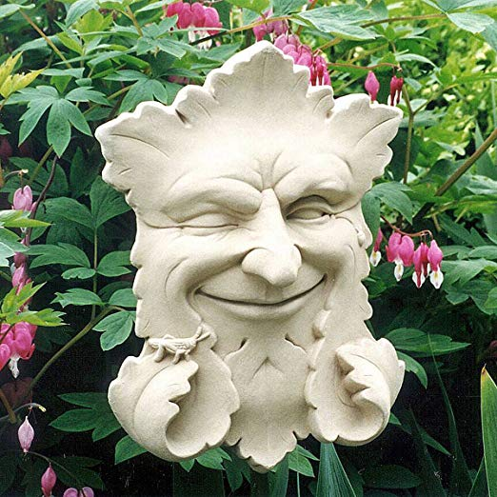 2. 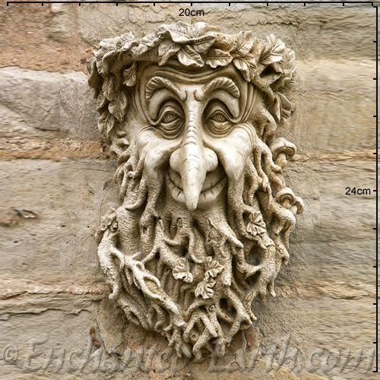

3. 4. 