Date: February 12, 2020
In your journal record the following:
SCULPTURE ENTRY #8:
ART THINK: Look at the Green Man examples below. Which one is your favorite? WHY?
Announcements/Reminders:
- Skull due TODAY!
- Journal check NEXT TIME!
Today’s Objective:
- Build armature
- Practice features
- Finishing skull & check off
- Get started on Green Man (if you finish)

- 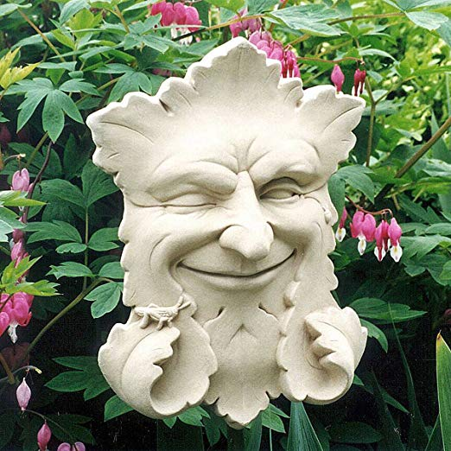 2. 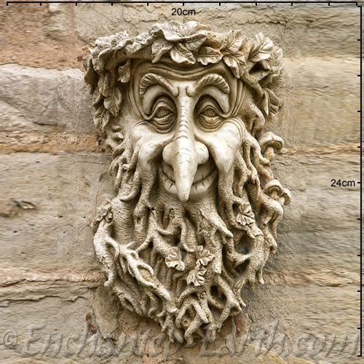

3. 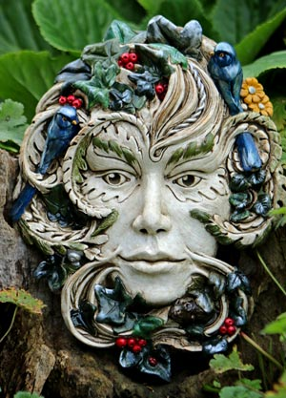 4. 