Date: January 30, 2019
In your journal record the following:
SCULPTURE ENTRY #4:
ART THINK: Look at the art works below and see if you can guess how or what materials they were created with.
Announcements/Reminders:
- CHANGE: Tara Donavan project due Feb. 5th
Today’s Objective:
- Watch clip
- Work on Tara Donavan project
Homework: None today unless you missed an assignment.

1. 2.
3. 4. 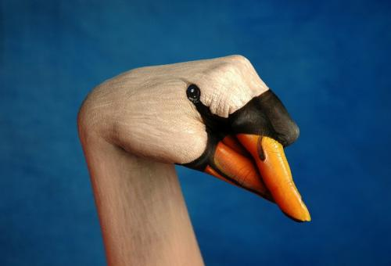
5.