Date: Jan. 31, 2020
In your journal record the following:
SCULPTURE ENTRY #4:
ART THINK: Look at the sculptures below and see if you can guess what they are made from:
Announcements/Reminders:
- If you have not taken care of your fee, you will have a bookwork project when we start to work with clay!
- Tara Donavan project due NEXT TIME!
Today’s Objective:
- Watch clip
- Work on your Tara Donavan project.

1. 2.
3. 4. 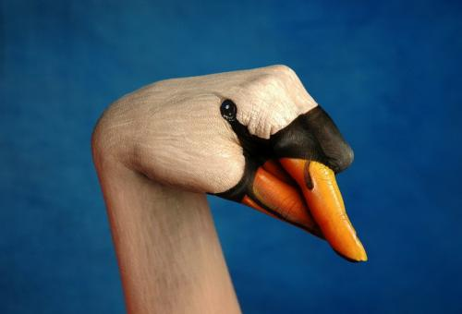
5.