Date: Mar 27, 2018
In your journal record the following:
SCULPTURE ENTRY #22:
ART THINK: Look at the cardboard relief sculptures below and tell me which fits the criteria for this assignment the best and WHY?
Announcements/Reminders:
- SHHS Art Show entries DUE TOMORROW!!!
Today’s Objective:
- Talk about criteria (pass out task sheets)
- Work on cardboard relief sculpture
Homework: Get caught up if you are behind.

1. 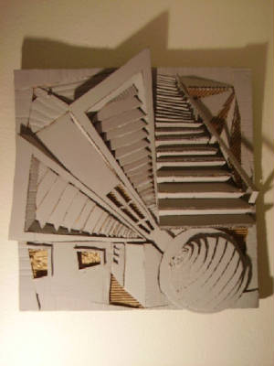 2. 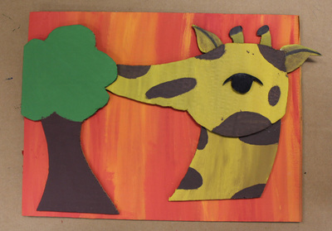
3. 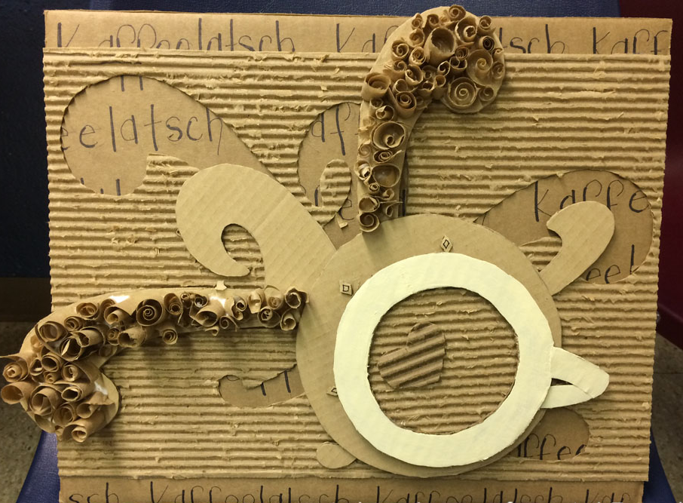 4. 