Date: Oct 26, 2020
In your journal, record the following:
SCULPTURE ENTRY #21:
ART THINK: Look at the Halloween mask designs below. Which do you like the best and WHY?
Announcements/Reminders:
- Surreal Hands due NEXT TIME!
- Check your grades – let me know ASAP if there is a mistake!
Today’s Objective:
- Finish Surrealistic Hand
- Decide Sculptor to research if finished.

1. 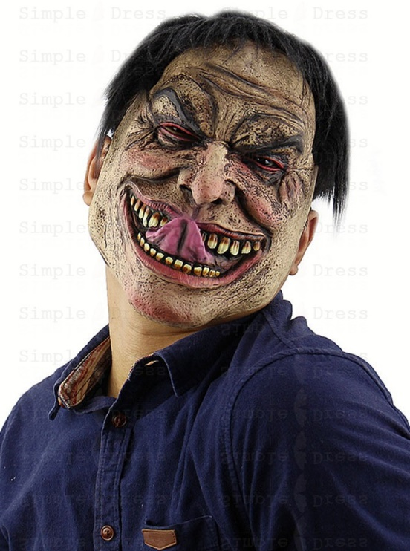 2. 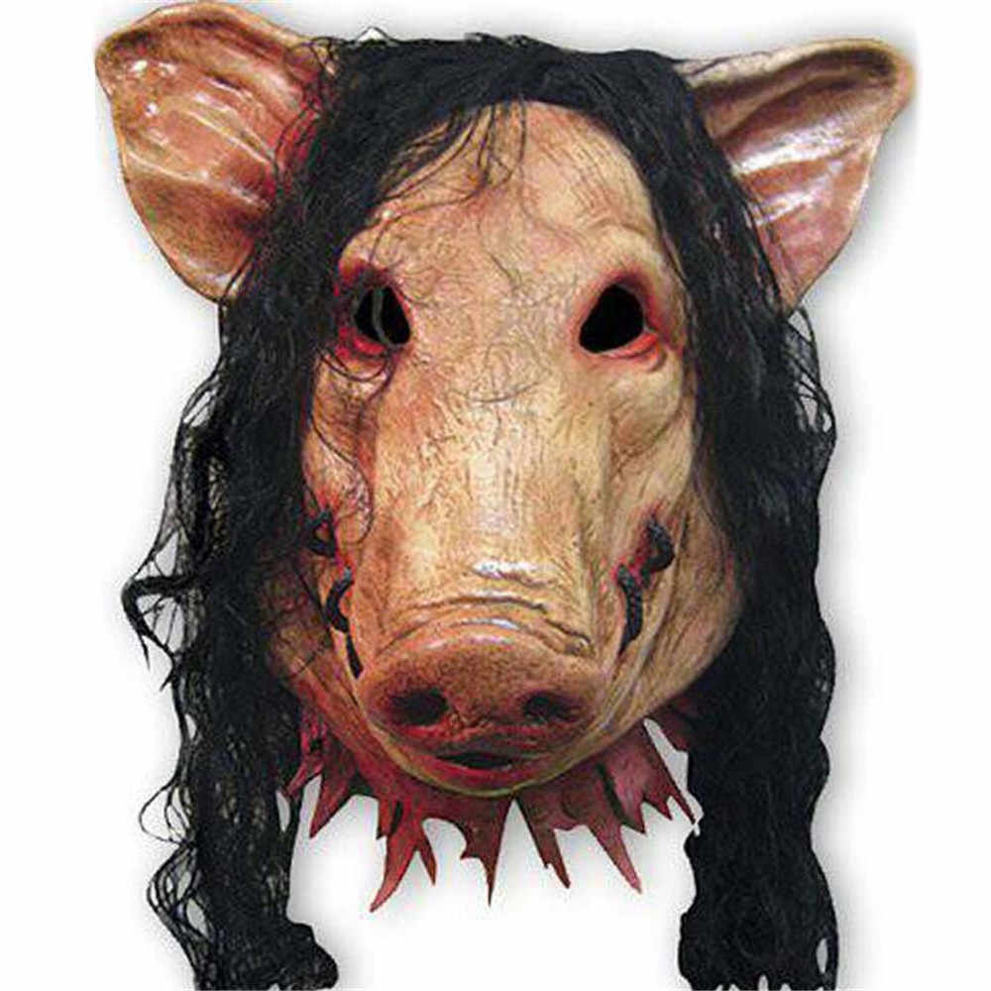
3. 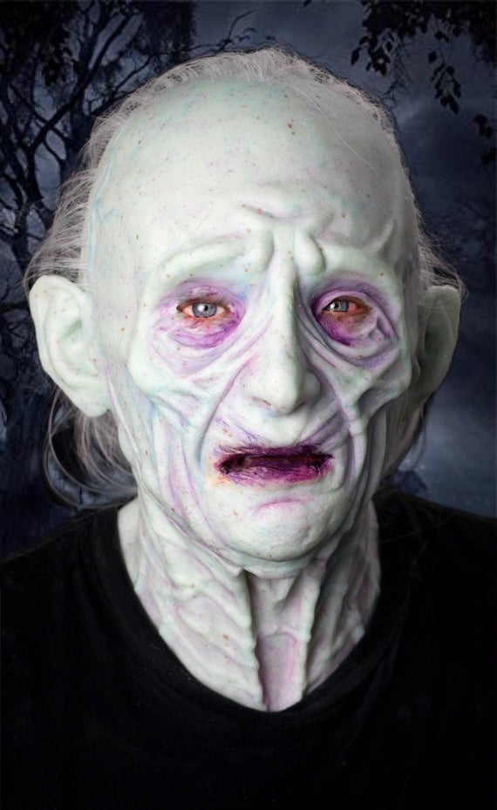 4. 