Date: Oct 14, 2020
In your journal, record the following:
SCULPTURE ENTRY #18:
ART THINK: If you had to explain your “artistic style” to someone, what would you say?
Announcements/Reminders:
- Surreal Hand due on October 22nd
- Oct 23 is the last day to turn in late work for this term.
Today’s Objective:
- Watch clip
- Work on Surrealistic Hand

- 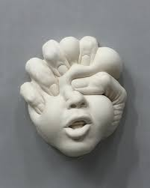 2. 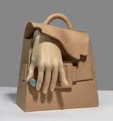
3. 4. 