Date: Mar 12, 2018
In your journal record the following:
SCULPTURE ENTRY #17:
ART THINK: What sculpture project would you like to do next and WHY? (Look at ideas below or come up with one of your own.)
Announcements/Reminders:
- TODAY is the last day to turn in late work for this term!
- Food sculpture is due on March 19th.
Today’s Objective:
- Talk about art classes offered next year.
- Talk about using references to create texture (watch clip).
- Work on food with texture sculpture.
Homework: CHECK YOUR GRADE! (Let me know ASAP if there is a mistake.)

- (figures) 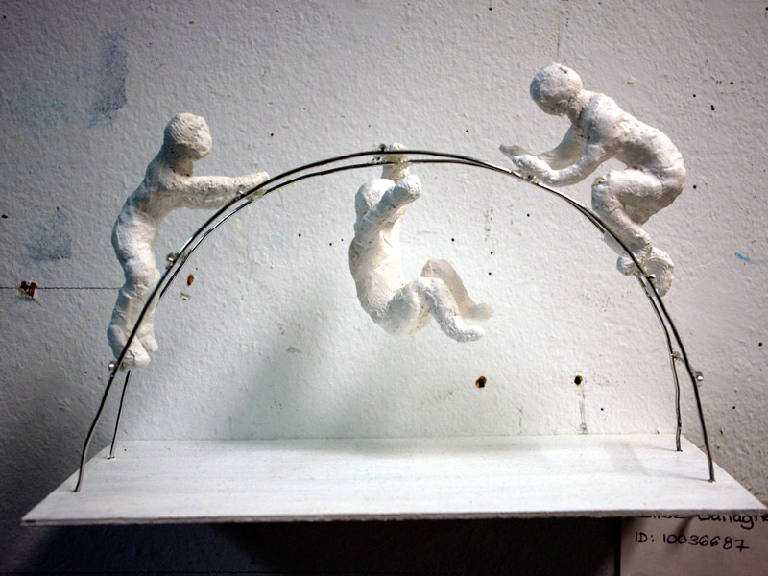
- (paper plate sculptures) 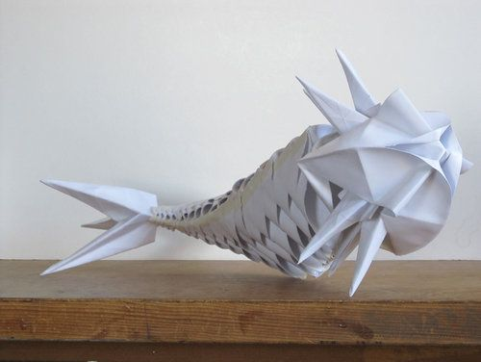
- (polymer clay animals) 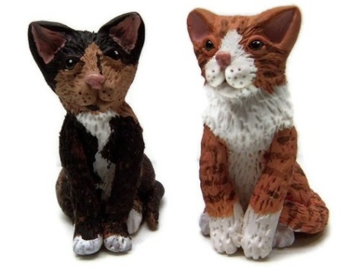
4.(packing tape sculptures) 