Date: Mar 8, 2018
In your journal record the following:
SCULPTURE ENTRY #16:
ART THINK: Claus Oldenburg was an artist that liked to sculpt food. Take a look at some Claus Oldenburg sculptures below, tell me which one you like the best and WHY.
Announcements/Reminders:
- NEXT TIME is the last day to turn in late work for this term!
- Food sculpture is due on March 19th.
Today’s Objective:
- Talk about finishing green man.
- Work on food with texture sculpture.
Homework: Get any late work ready to turn in.

1.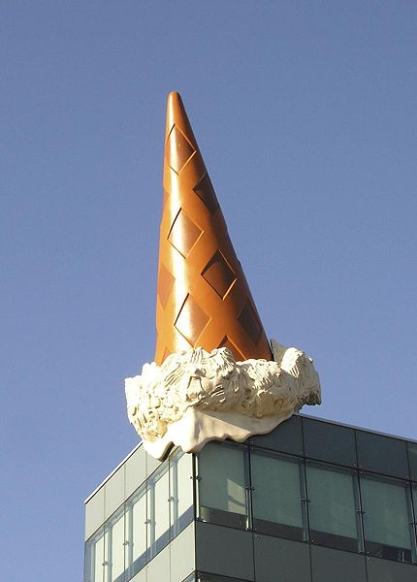 2.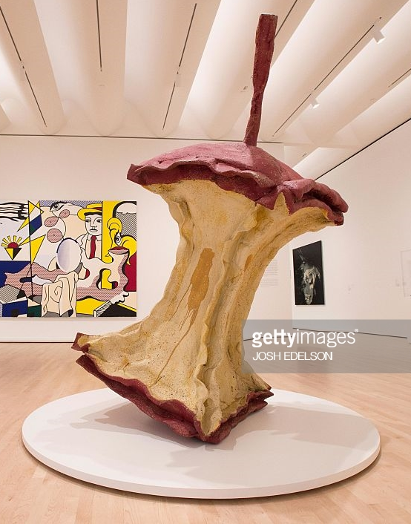
3.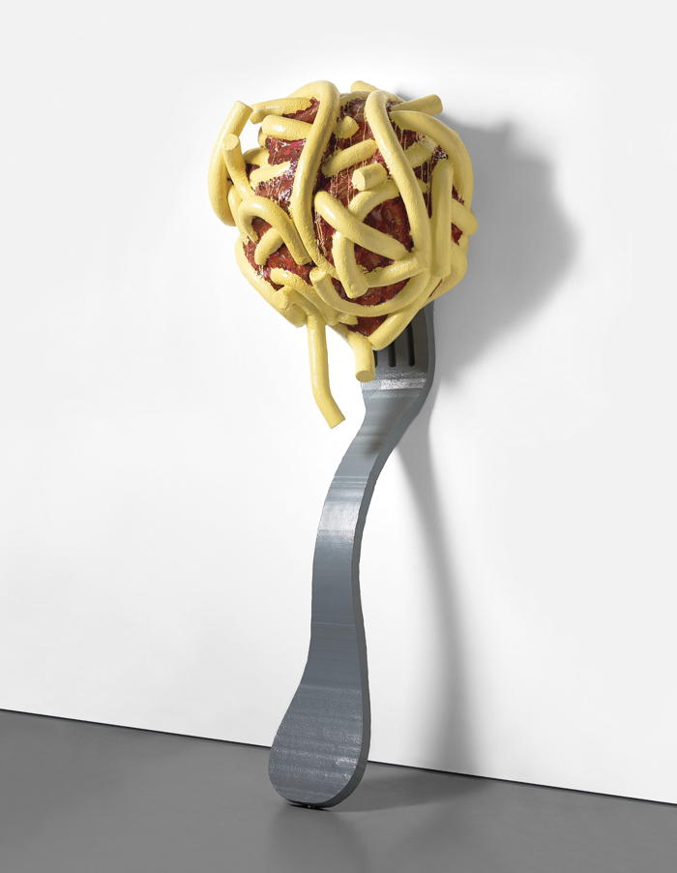 4. 