Date: Sept. 30, 2021
In your journal, record the following:
SCULPTURE ENTRY #13:
ART THINK: Answer the questions below:
Announcements/Reminders:
- Surreal Hand due October 12th
Today’s Objective:
- Watch clip
- Work on your Surrealistic Hand project

The surface of your clay does not always have to be smooth. Which textures do you like the best and WHY?
1. 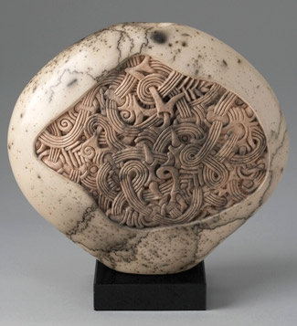 2. 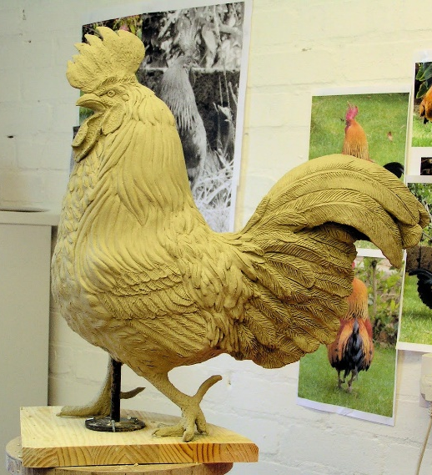
3. 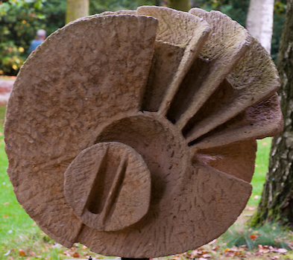 4. 