Date: February 20, 2019
In your journal record the following:
SCULPTURE ENTRY #11:
ART THINK: How good are you at reading facial expressions, guess the emotion shown on each face:
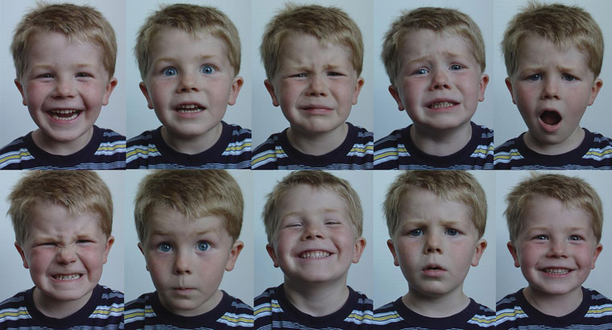
Announcements/Reminders:
- Green Man is due March 1st
Today’s Objective:
- Talk about facial expressions (watch clip)
- Work on Green Man
Homework: None

