**Date: February 21, 2020**

**In your journal record the following:**

**SCULPTURE ENTRY #11:**

**ART THINK: What emotion do you associate with each of these faces?**

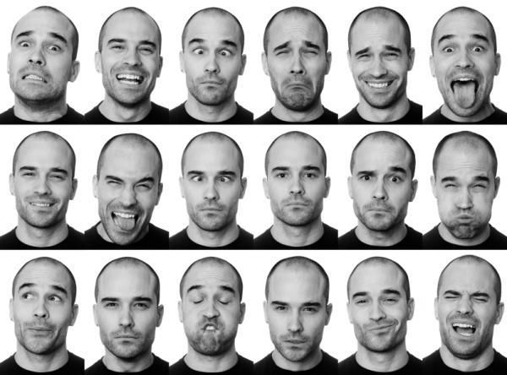

1

2

3

4

5

6

**Announcements/Reminders:**

1. **Field trip on March 6th (to the All-State High School show and the BYU Museum of Art). Get your release signed and returned ASAP if you want to go.**

**Today’s Objective:**

1. Watch clip
2. Work on Green Man
3. 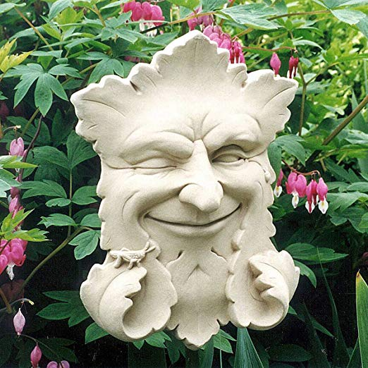 2. 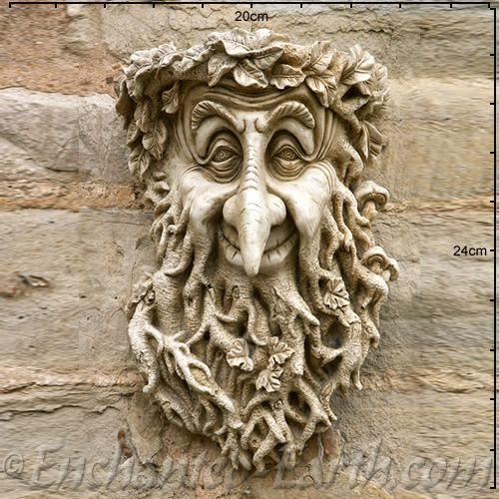

3.  4. 