Date: February 19, 2020
In your journal record the following:
SCULPTURE ENTRY #10:
ART THINK: How are you going to incorporate nature into your face? (In other words, what is the “green” in your Green Man?)
Announcements/Reminders:
- Field trip on March 6th (to the All-State High School show and the BYU Museum of Art).
Today’s Objective:
- Watch clip
- Work on Green Man

- 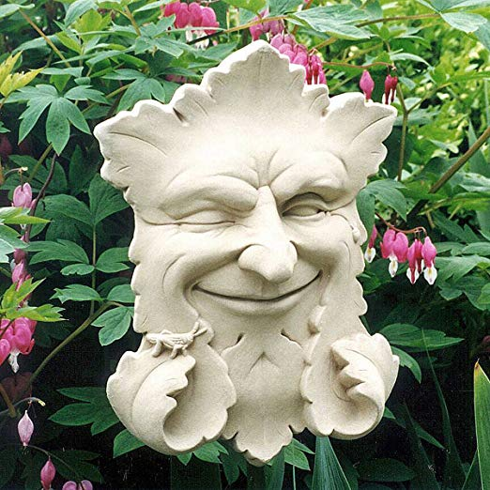 2. 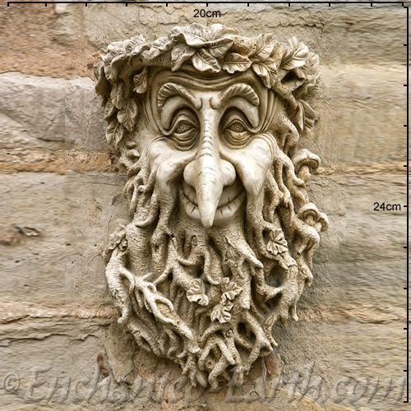

3. 4. 