October 8, 2018 Journal Entry 15
PRINTMAKING
- ART THINK: You must try at least 3 different ways to print and finish your Lino Cut Print. What are some things you could try?
Now record on your Assignment/Homework Log the following:
Assignment/Homework | Due Date
Change: Final Lino Cut Project | October 12th

Discuss objectives for the day or what we will try to get done: (no need to write down)
- Show examples of creative ways to print (look at Power Point)
- Work on Lino Cut project

- 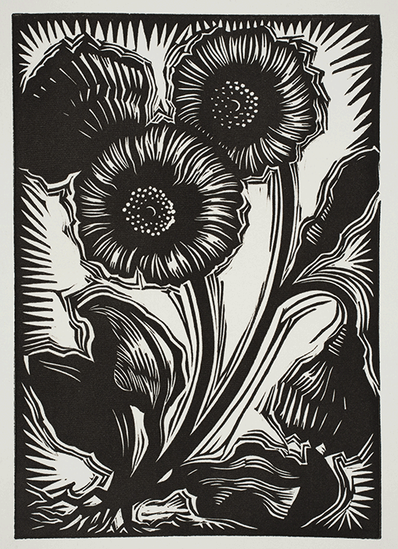 2. 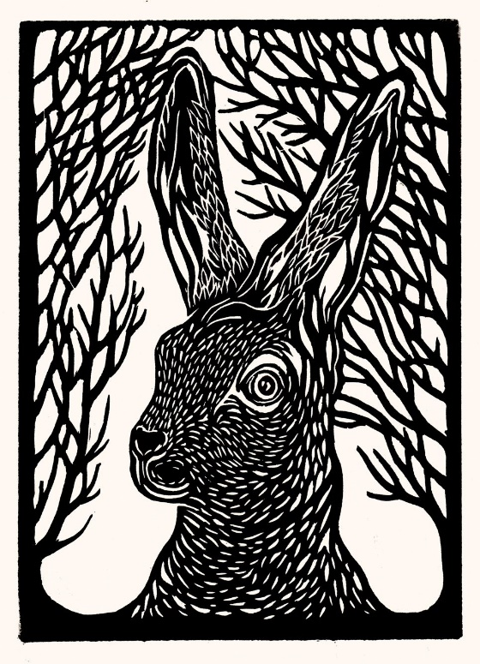
3. 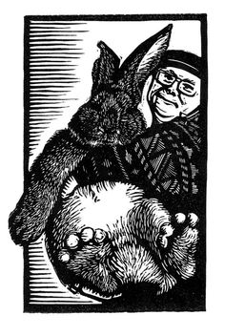 4. 