October 4, 2018 Journal Entry 14
PRINTMAKING
- ART THINK: Negative space is almost as important as positive space in a print. Look at the prints below and tell me which you think made the best use of their negative space and WHY?
Now record on your Assignment/Homework Log the following:
Assignment/Homework | Due Date
CHANGE: Lino Cut Project | October 10th

Discuss objectives for the day or what we will try to get done: (no need to write down)
- Talk about different ways to print.
- Work on Lino Cut project

- 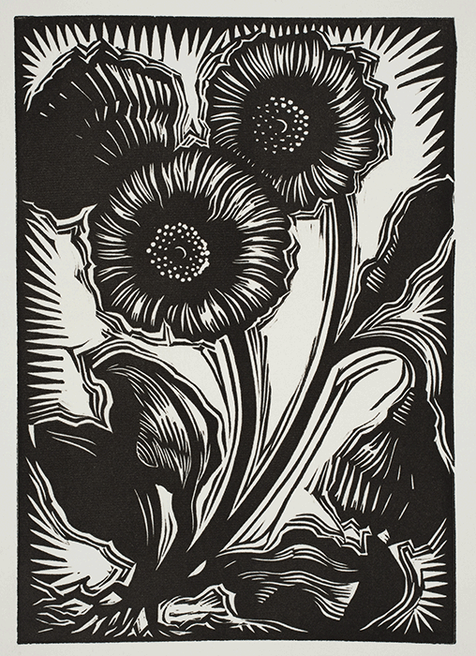 2. 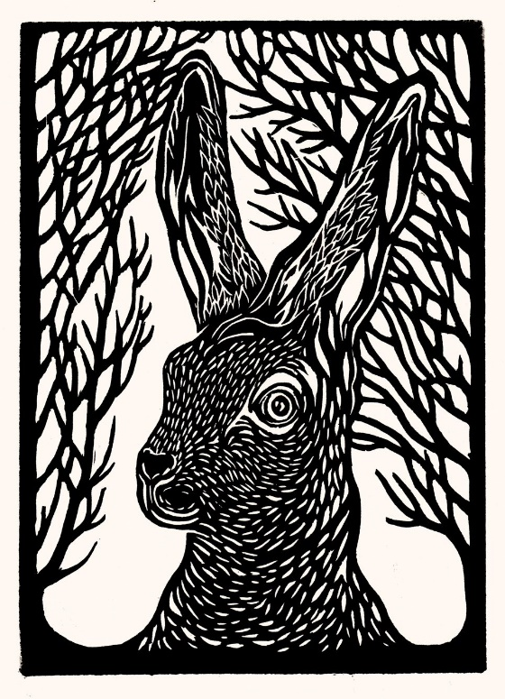
3. 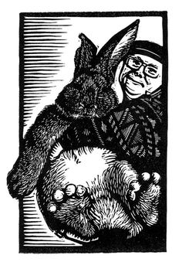 4. 