Sept. 19 & 20, 2018
PAINTING
Journal Entry #9
- ART THINK: See if you can identify the parts of the lighting on the sphere below:
Now record on your Assignment/Homework Log the following:
Assignment/Homework | Due Date
Journal check | Next time
CHANGE: Cherry Painting | Sept., 25th
HW: reference picture for silhouette | Sept., 25th

Discuss objectives for the day or what we will try to get done: (no need to write down)
- Explain homework
- Talk about parts of light and looking closely at your reference.
- Work on Cherry painting.

Can you identify the parts of the modeling on this sphere?

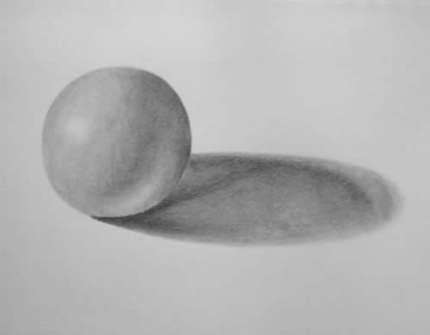
4.
2.
1.
3.

