Sept. 17 & 18, 2018
PAINTING
Journal Entry #8
- ART THINK: Look at the 3 paintings below and answer the questions:
Now record on your Assignment/Homework Log the following:
Assignment/Homework | Due Date
Journal check | Sept. 21st
CHANGE: Cherry Painting | Sept., 25th

Discuss objectives for the day or what we will try to get done: (no need to write down)
- Review Cherry Painting steps
- Work on Cherry painting.

- 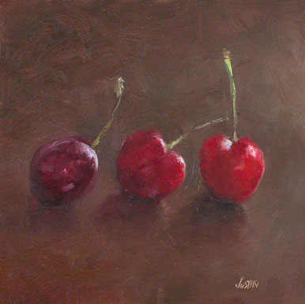
Choose the following and JUSTIFY YOUR ANSWER:
- Best composition – WHY?
- Best choice for background – WHY?
- Most real looking – WHY?

- 
 