Dec 17 & 18, 2019
PAINTING
Journal Entry #39
ART THINK: Review: What does it mean when I say, “We paint light NOT objects”?
ANNOUNCEMENTS/REMINDERS:
- Journal check NEXT TIME!
OBJECTIVES:
- Watch clip (mixing colors)
- Work on Altered Portraits

- 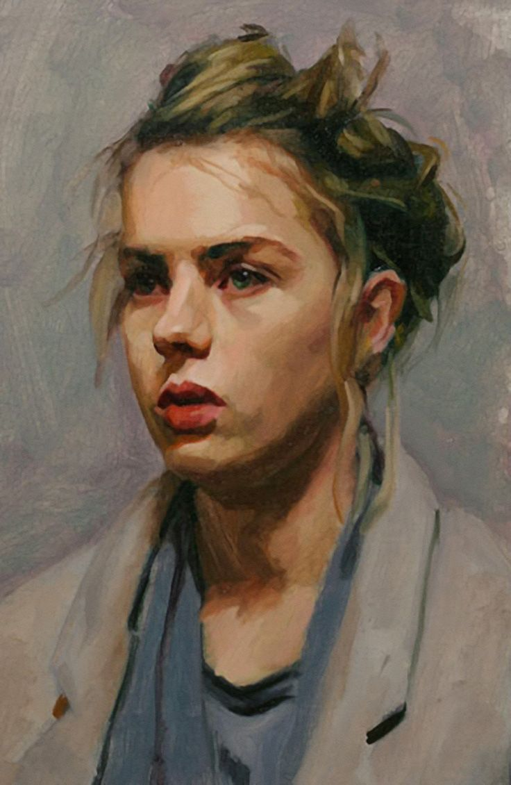 2. 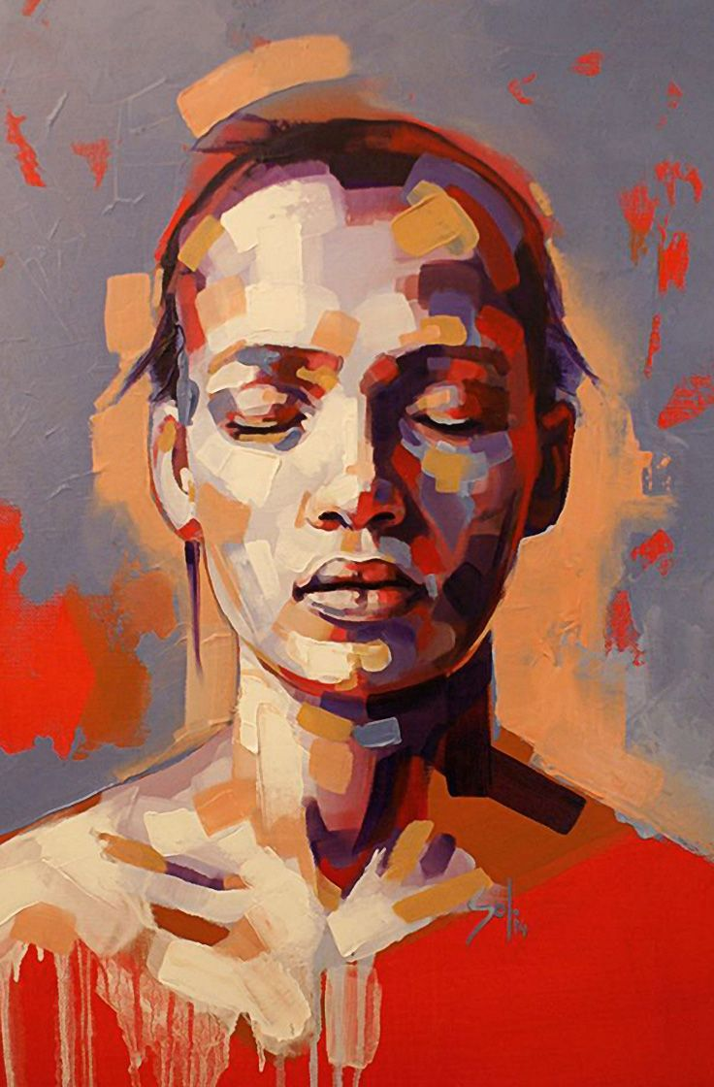
- 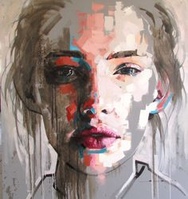 4. 