Dec 13 & 16, 2019
PAINTING
Journal Entry #38
ART THINK: Look at the portraits below. Which artwork do you like the best and WHY?
ANNOUNCEMENTS/REMINDERS:
- Journal check December 19th
OBJECTIVES:
- Watch clip
- Work on Altered Portraits

- 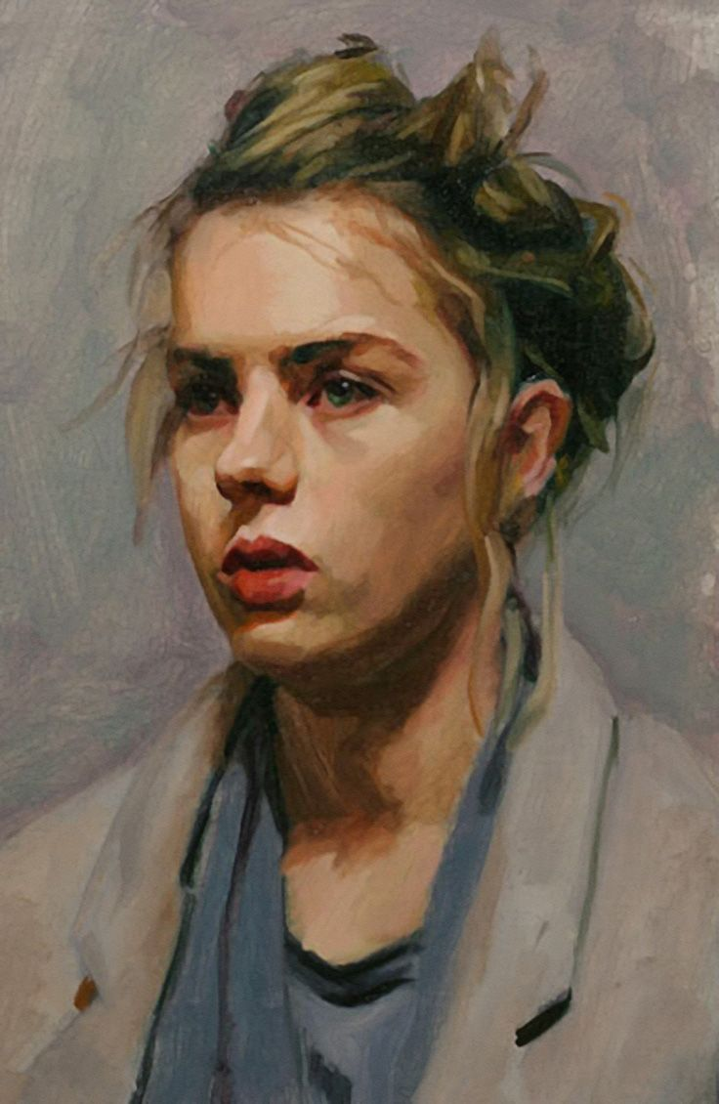 2. 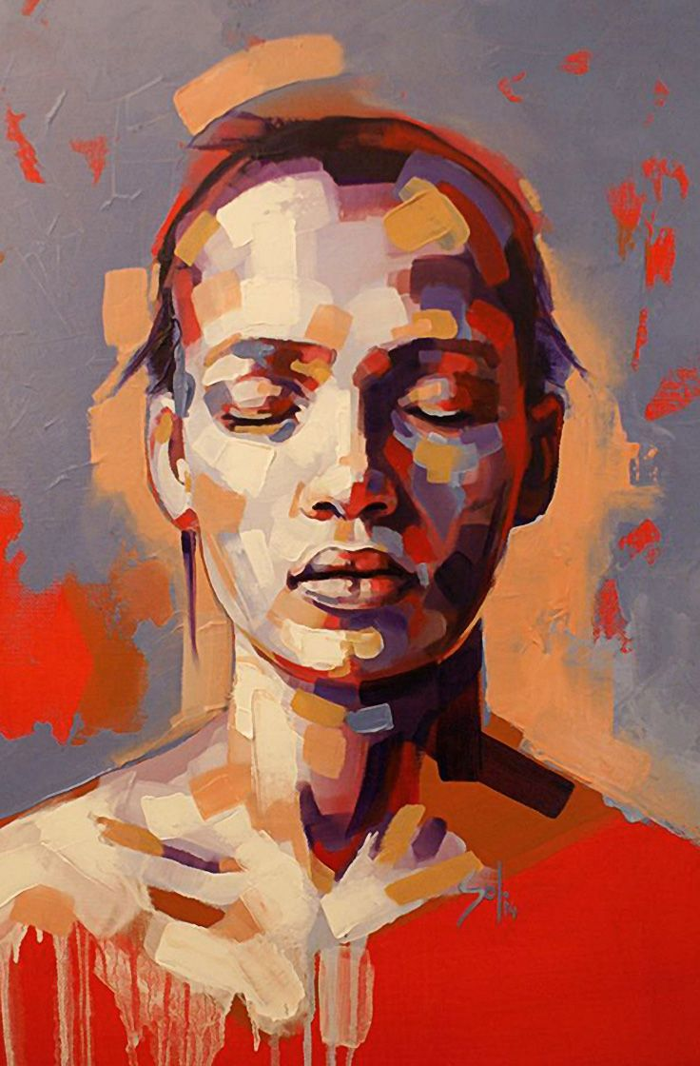
- 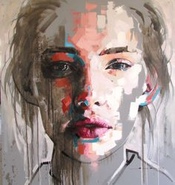 4. 