Dec 5 & 6, 2019
PAINTING
Journal Entry #35
ART THINK: What do you still need to do to finish your Cropped Image?
ANNOUNCEMENTS/REMINDERS:
- Cropped Image Paintings due NEXT TIME!
- If you have not turned in your reference photo of a face, please do it ASAP!
OBJECTIVES:
- Finishing Cropped Image

1. 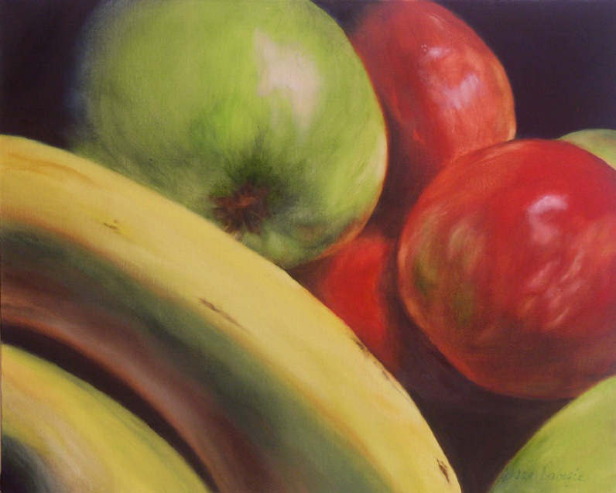
2. 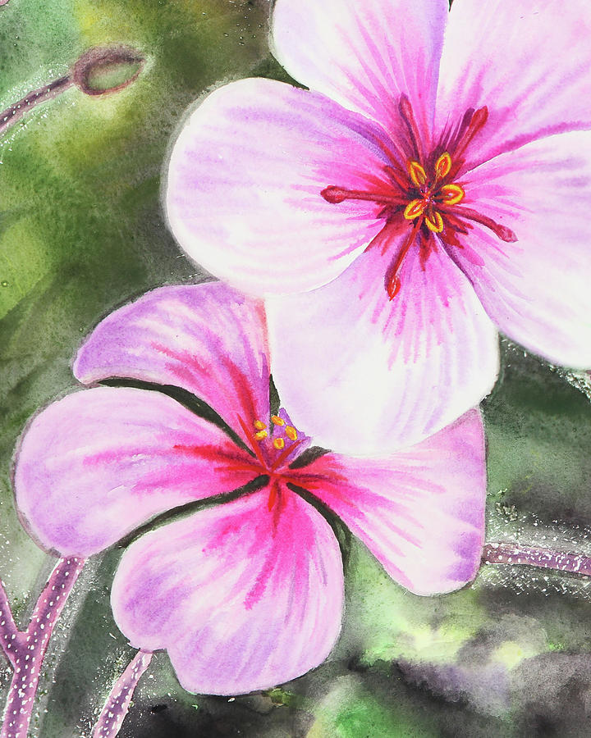 3. 