Dec 3 & 4, 2019
PAINTING
Journal Entry #34
ART THINK: What do you still need to do to finish your Cropped Image?
ANNOUNCEMENTS/REMINDERS:
- Cropped Image Paintings due Dec. 9th
- DUE TODAY: An 8x10, grayscale copy of a face TURN IN TO THE BASKET BY 3:00 TODAY (with your name and class period on the back)!
OBJECTIVES:
- Work on Cropped Image

1. 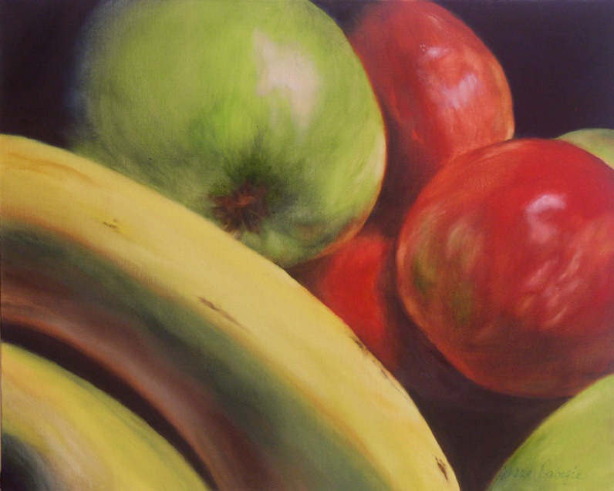
2. 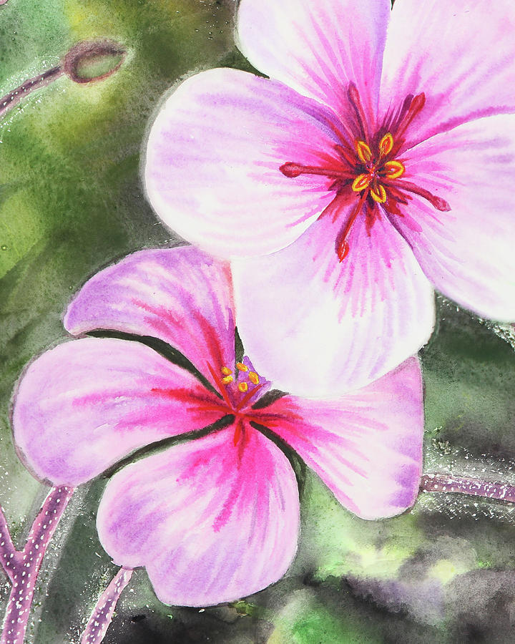 3. 