Nov 26 & Dec 2, 2019
PAINTING
Journal Entry #33
ART THINK: Which of the following cropped images painting do you think shows the best realistic, consistent lighting?
ANNOUNCEMENTS/REMINDERS:
- CHANGE: Cropped Image Paintings are due on December 9th
- HOMEWORK: Bring an 8x10, grayscale copy of a face for next time! (You will be turning this in.)
OBJECTIVES:
- Work on Cropped Image

1. 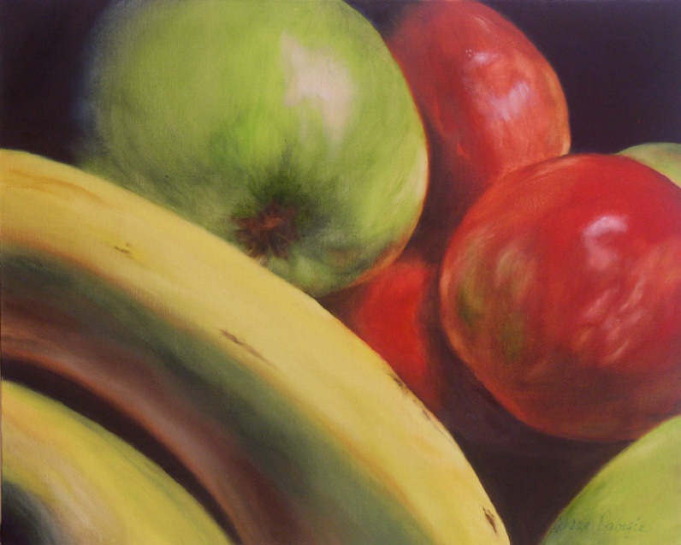
2. 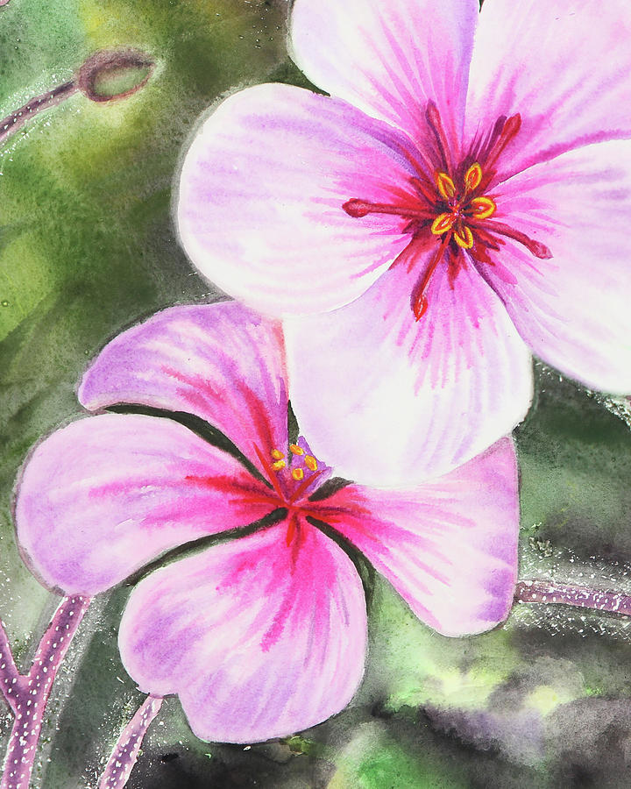 3. 