Date: December 6 & 7, 2017
In your journal record the following:
PAINTING ENTRY #33:
ART THINK: Look at the paintings below and tell me which one do you connect with the most and WHY?
Announcements/Reminders:
- Cropped Images due Dec. 18th
- Journal check NEXT TIME!
Today’s Objective:
- Watch time lapse cropped image painting.
- Work on cropped image
Homework: Get caught up if you are behind.

1. 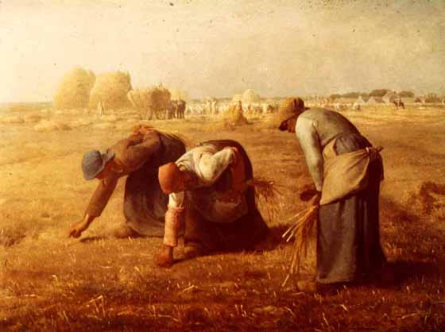 2. 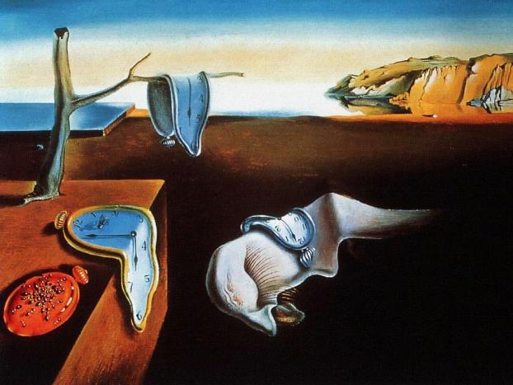3. 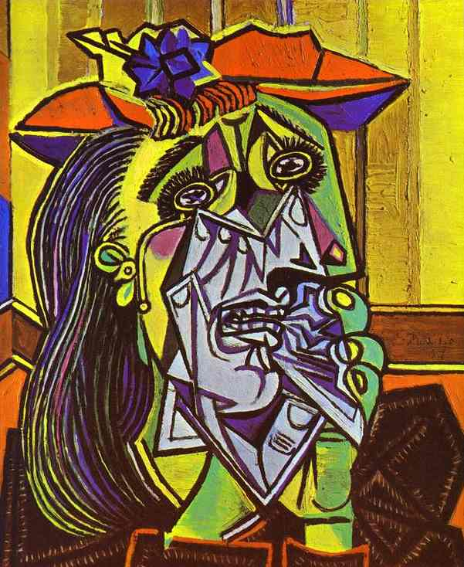4. 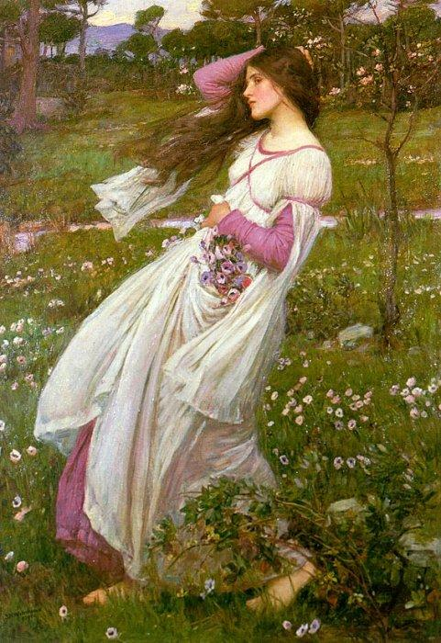 5. 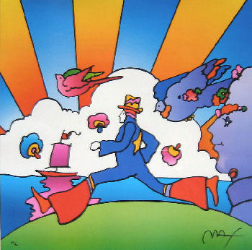
6. 