November 27 & 28
PAINTING
Journal Entry #31
ART THINK: Pretend the paintings below were in an art competition and you are the juror. Which painting would you choose for 1st place and WHY?
Now record on your Assignment/Homework Log the following:
Assignment/Homework | Due Date
Landscape Paintings | TODAY (last day w/o contract)
DUE: journal check | TODAY

Discuss objectives for the day or what we will try to get done: (no need to write down)
- Review
- Working on Cropped image

- 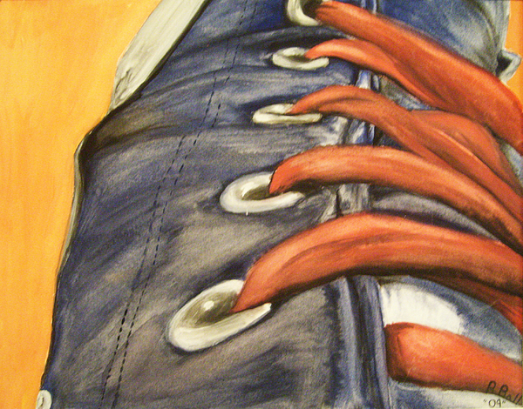 2. 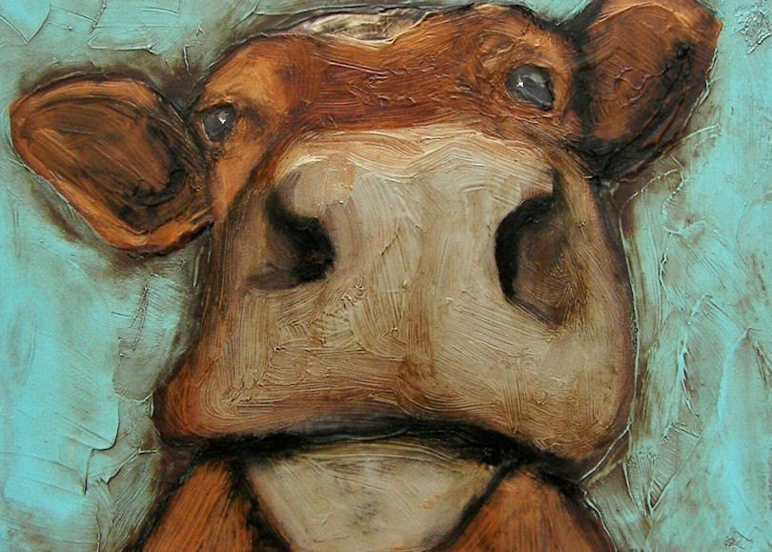 3. 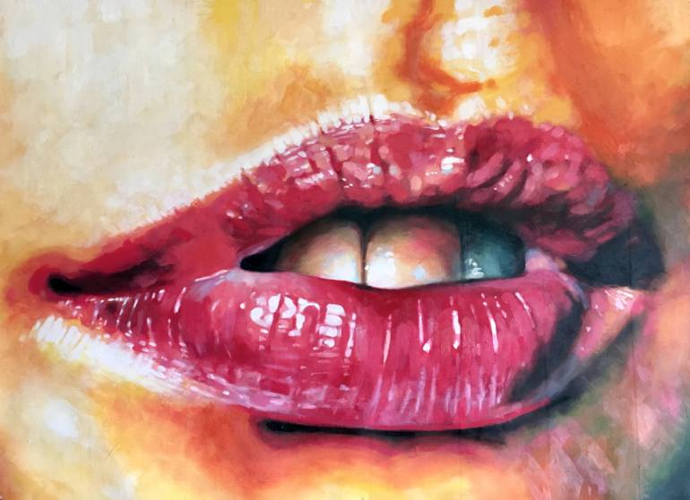 4. 