Nov 18 & 19, 2019

PAINTING

Journal Entry #30

ART THINK: **See if you can guess the textures below:**

* ANNOUNCEMENTS/REMINDERS:
* Landscape Paintings are now past due – turn in ASAP if you have not already!

OBJECTIVES:

1. Review
2. Work on Cropped Image

1. 2.

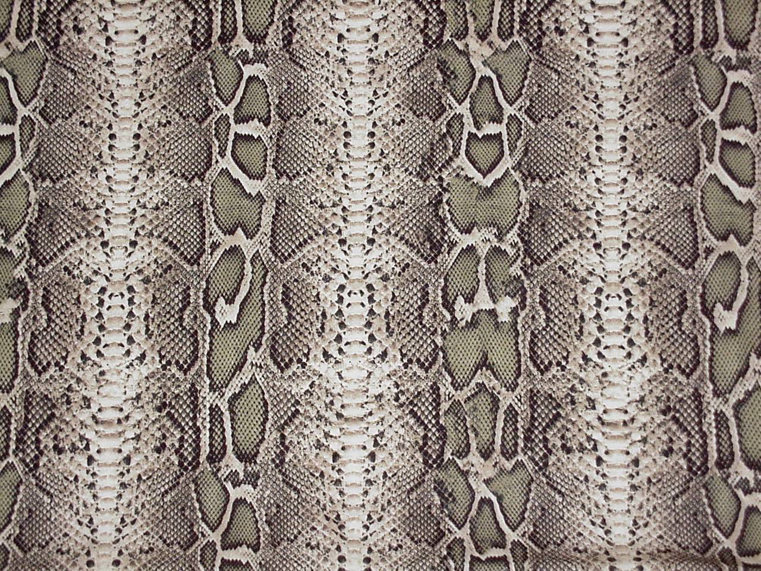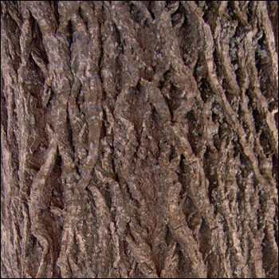

3. 4.

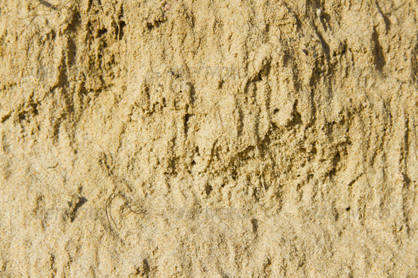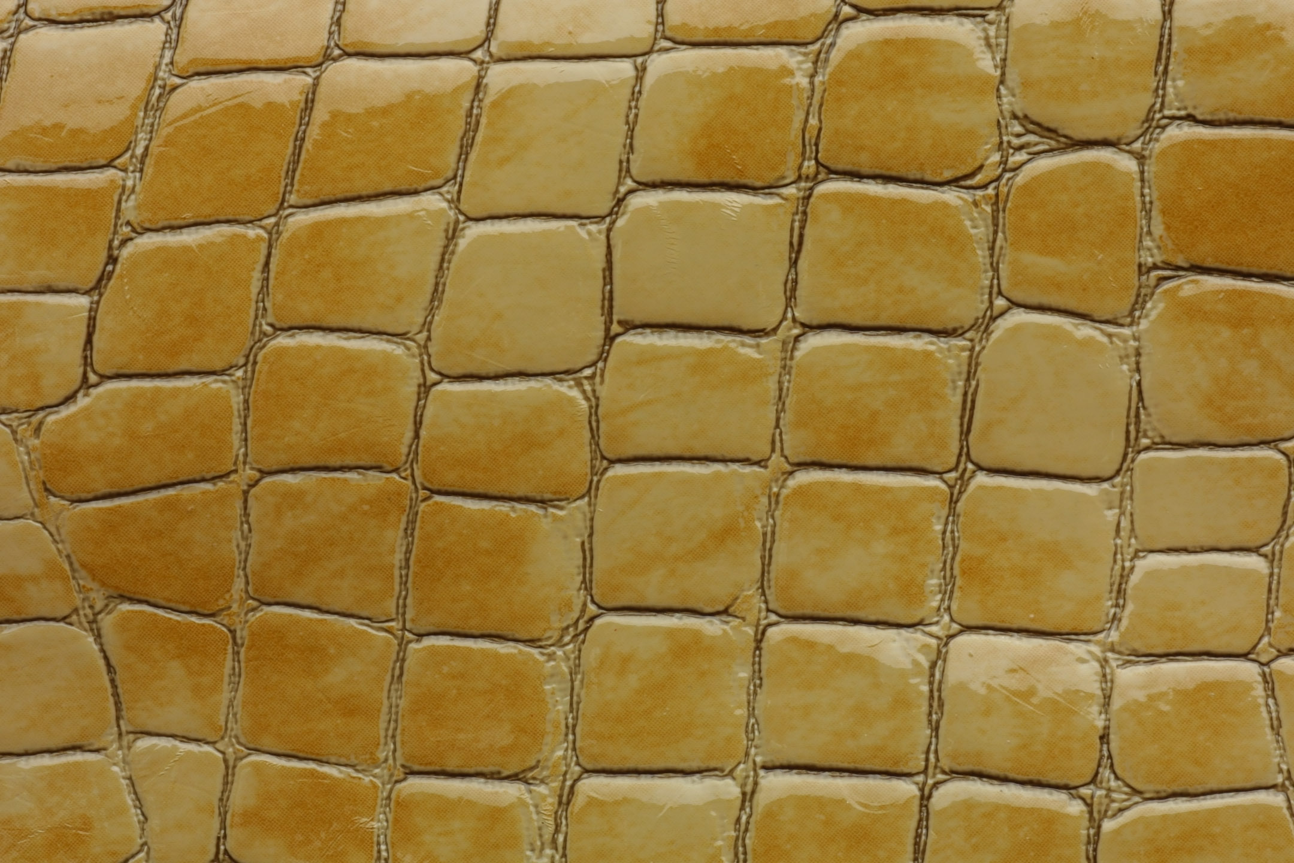

5. 