Oct 1 & 4, 2021
PAINTING
Journal Entry #14
- ART THINK: Look at the grisaille paintings below. Which do you think is the most effective and WHY?
ANNOUNCEMENTS/REMINDERS:
- Take or find reference photos for landscape painting (DUE: October 11th)
OBJECTIVES:
- Finish Under Painting (grisaille)

1. 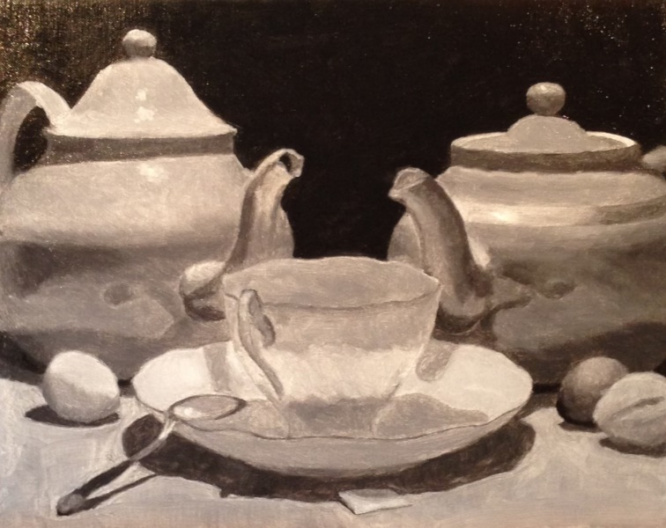 2. 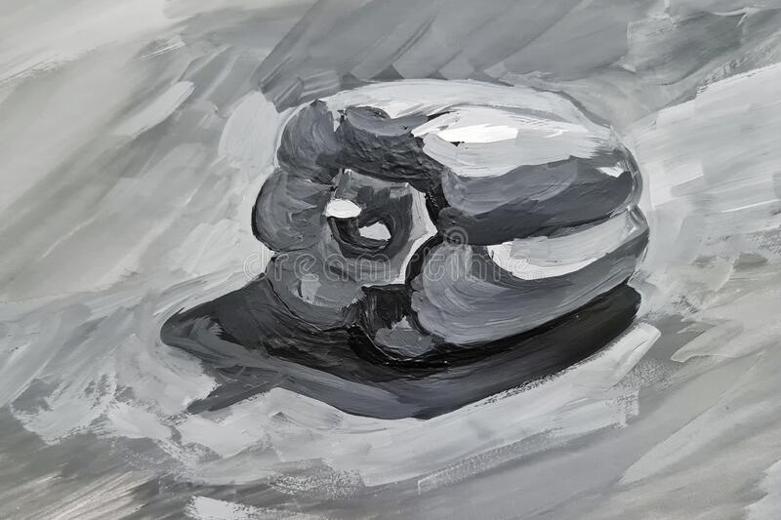

3. 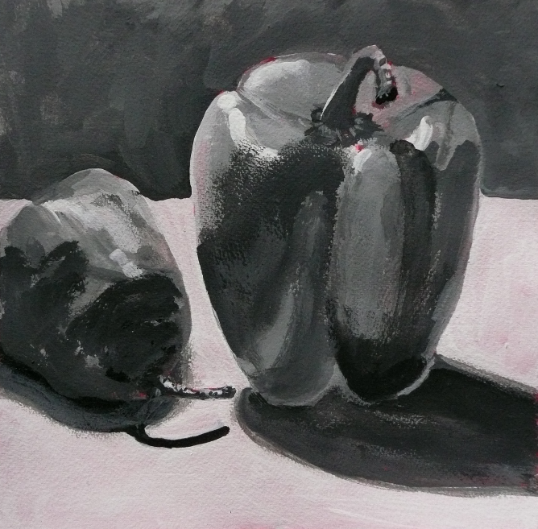 4. 