Sept. 25, 2019
PAINTING
Journal Entry #12
- ART THINK: Where is your happy place? Describe what it is like to be there.
ANNOUNCEMENTS/REMINDERS:
- Find reference images for your landscape painting (due Oct 3)
OBJECTIVES:
- Watch clips of next step
- Put in background
- Begin adding color to your cherry

- 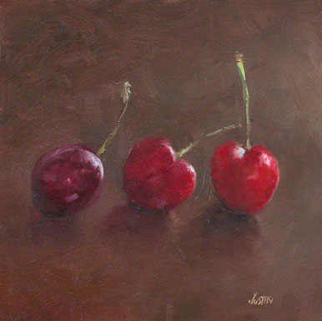
Choose the following and JUSTIFY YOUR ANSWER:
- Best composition – WHY?
- Best choice for background – WHY?
- Most real looking – WHY?

- 
 