Sept. 21 & 24, 2018
PAINTING
Journal Entry #10
- ART THINK: How would you finish this sentence: “Learning to paint takes…” then explain your answer.
Now record on your Assignment/Homework Log the following:
Assignment/Homework | Due Date
Journal check | Next time
CHANGE: Cherry Painting | Sept., 25th
HW: reference picture for silhouette | Sept., 25th

Discuss objectives for the day or what we will try to get done: (no need to write down)
- Review homework
- Talk about finishing up Cherry Painting
- Finishing up Cherry painting.

Can you identify the parts of the modeling on this sphere?

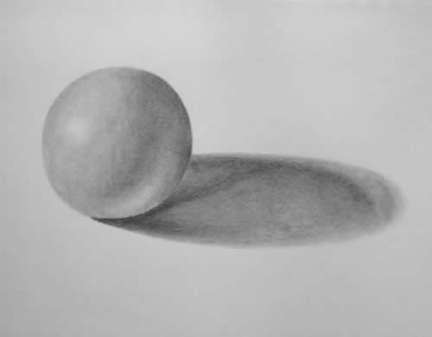
4.
2.
1.
3.

