Date: February 14, 2017
In your journal record the following:
PAINTING II JOURNAL ENTRY #8:
Art Think: Look at the paintings below and answer the questions:
Announcements/Reminders:
- Field trip on March 8th to BYU and Springville Art Museums (take a flyer if interested).
Today’s Objective:
- Talk about backgrounds.
- Work on background and start blocking in.
Homework: Get caught up if you are behind.

- 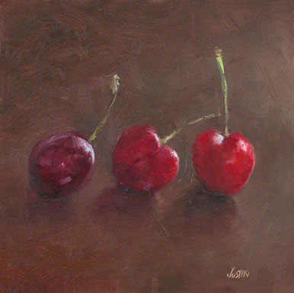
Choose the following and JUSTIFY YOUR ANSWER:
- Best composition – WHY?
- Best choice for background – WHY?

- 
 