Date: February 12, 2018
In your journal record the following:
PAINTING 2 JOURNAL ENTRY #8:
Art Think: Look at the paintings below: What is your favorite painting and WHY?
Announcements/Reminders:
- CHANGE: Monochromatic Value painting is due NEXT TIME! (Today is the last day we will work on it in class.)
- Field trip tomorrow (if you are coming meet here after 1st period).
Today’s Objective:
- Review color mixing
- Intro next project
- Finish monochromatic value painting and turn in.
- Start next project
Homework: Finish your painting if you don’t finish in class today.

1.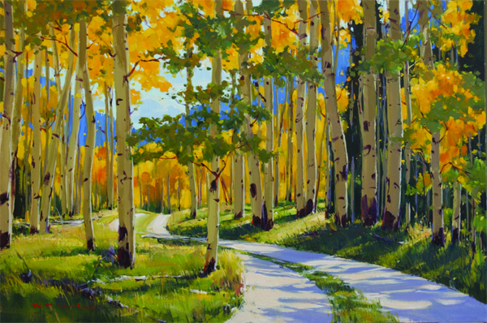 2. 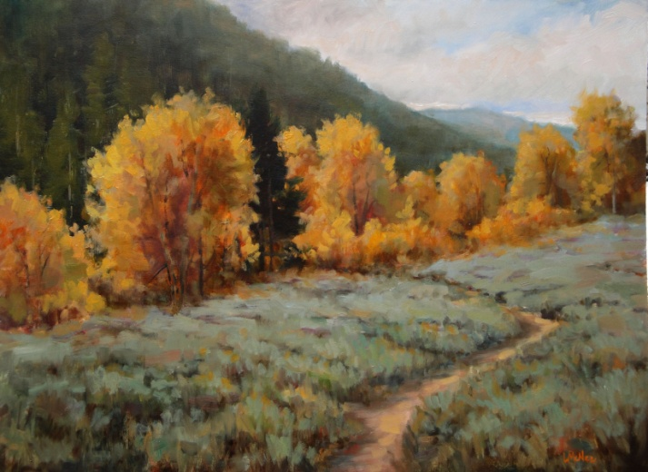
3.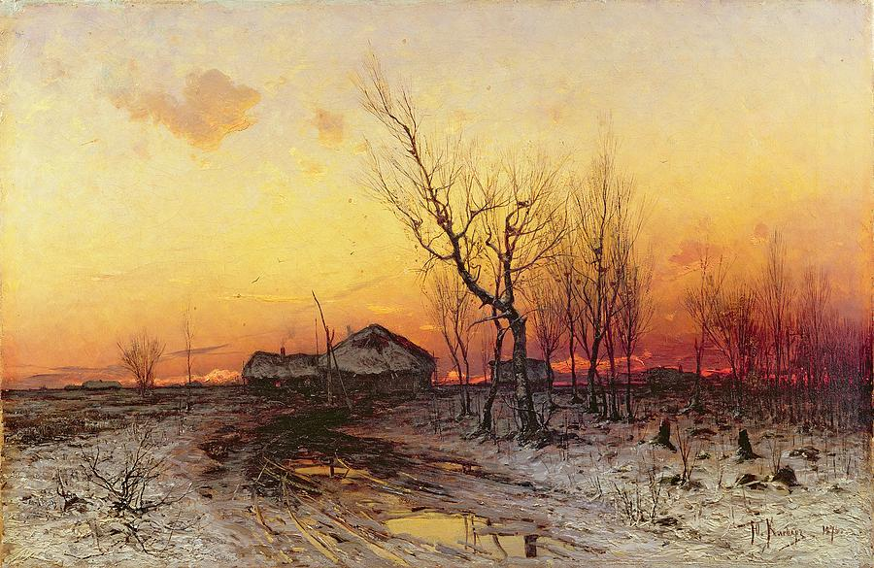4. 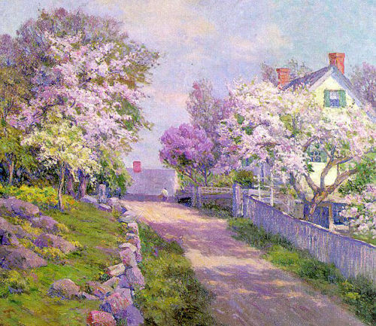
5.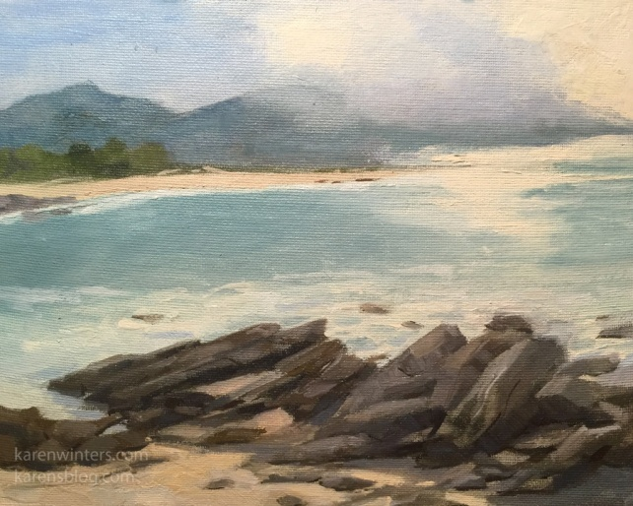 6. 