Date: February 6, 2018
In your journal record the following:
PAINTING 2 JOURNAL ENTRY #6:
Art Think: Look at the diagram below and see if you can fill in the missing terms.
Announcements/Reminders:
- Only 1 more day to finish Monochromatic Value painting
- Field trip Feb 13th - get release signed and returned ASAP if you plan to go.
Today’s Objective:
- Review light
- Work on monochromatic value painting
Homework: Get caught up if you have missed an assignment.

Can you identify the parts of the modeling on this sphere?

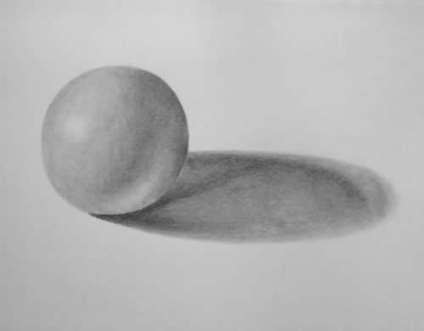
4.
2.
1.
3.

