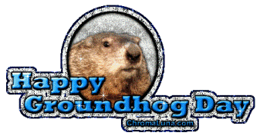 Date: February 2, 2018
In your journal record the following:
PAINTING 2 JOURNAL ENTRY #5:
Art Think: Finish these 2 sentences: “The most frustrating thing about working with oil paint is…” AND: “The best thing about working with oil paints is…”
Announcements/Reminders:
- Field trip Feb 13th - get release signed and returned ASAP if you plan to go.
Today’s Objective:
- Go over task sheet
- Work on monochromatic value painting
Homework: Get caught up if you have missed an assignment.

