Date: April 27, 2018
In your journal record the following:
PAINTING 2 JOURNAL ENTRY #31:
ART THINK: See if you can match the self portraits below to the correct artist:
Announcements/Reminders:
- Homework check TODAY!
- Jounal check TODAY!
- Last day to work on Emulate a Master painting in class is due MAY 1st.
Today’s Objective:
- Turn in journals
- Work on Emulate a Master painting
Homework: Get a reference picture for the portrait project (print as big as possible) if you forgot today.

See if you can match the artist to the self portrait:
1. Rembrandt 2. Vincent Van Gogh 3. Andy Warhol 4. Frieda Kahlo 5. Albrecht Durer 6. Pablo Picasso.
A.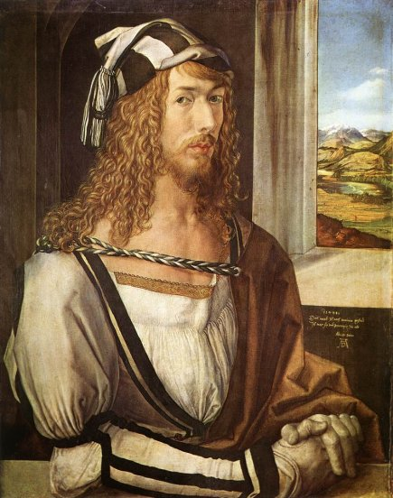B.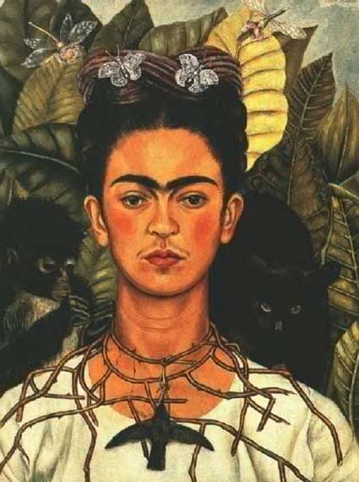C. 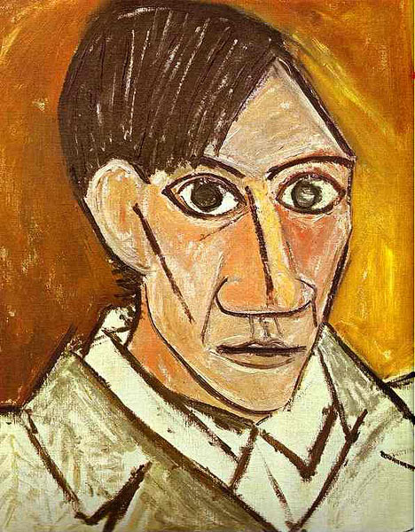

D.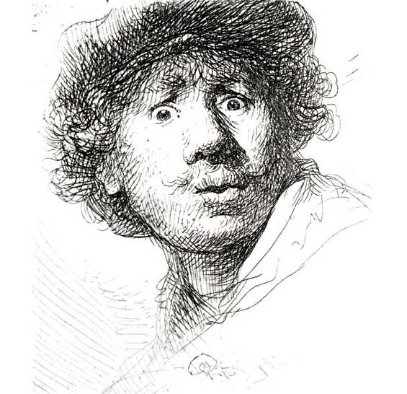E. 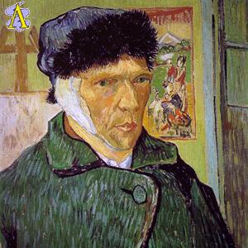F. 