Date: April 15, 2021
Record in your journal the following:
PAINTING 2 JOURNAL ENTRY: 26
Art Think: Look at the 3 sky paintings below. Which one do you think is the most effective and well done? WHY?
Announcements/Reminders:
- Remember to bring your charged chrome books to class every time.
Today’s Objective:
- Watch clip
- Working on sky
Homework: get caught up if you are behind.

1.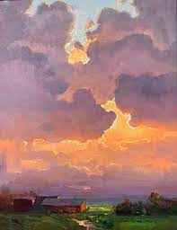 2. 

 