Date: April 21, 2017
In your journal record the following:
PAINTING II JOURNAL ENTRY #27:
ART THINK: Look at the artwork below and see if you can match the self-portrait to the artist.
Announcements/Reminders:
- If you haven’t checked off the reference photo for your face do it TODAY!
Today’s Objective:
- Draw your portrait (with values) on your canvas. (You may trace facial features if it is your own photograph.)
- Spray with fixative.
- Block in background.
Homework: Get caught up if you are behind.

1. Rembrandt 2. Vincent Van Gogh 3. Andy Warhol 4. Frieda Kahlo 5. Albrecht Durer 6. Pablo Picasso.
A.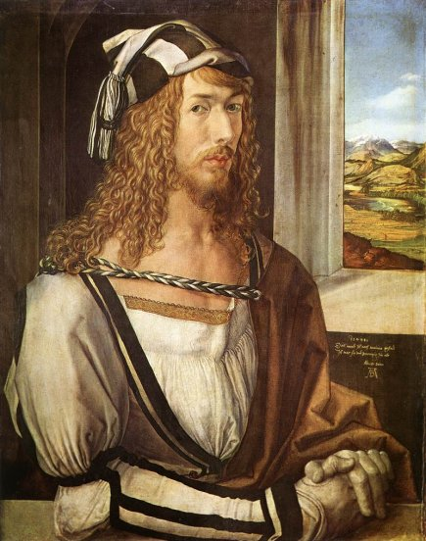B.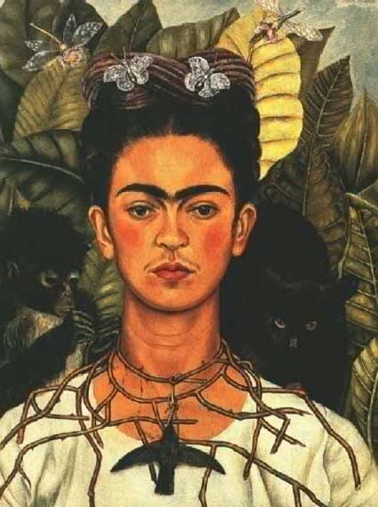C. 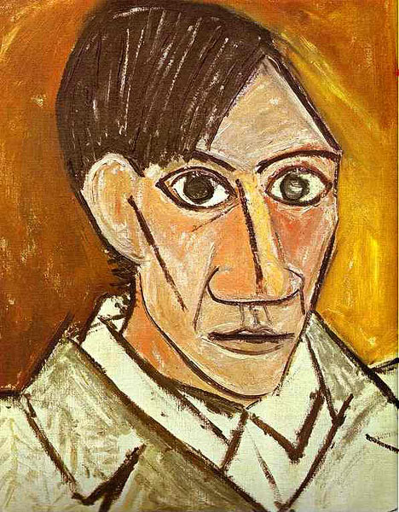

D.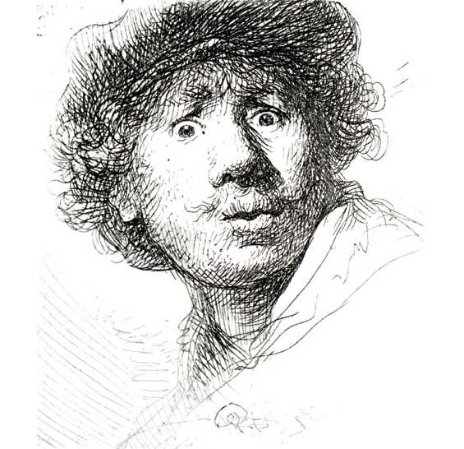E. 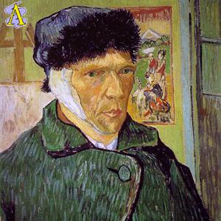F. 