Date: March 22, 2021
Record in your journal the following:
PAINTING 2 JOURNAL ENTRY: 20:
Art Think: Look at the 3 portraits below. Which do you think is the most effective and WHY?
Announcements/Reminders:
- TODAY is the last day to turn in late work for this term!
Today’s Objective:
- Watch clip
- Work on Portrait painting (begin refining face)
Homework: Get caught up if you are behind.

1.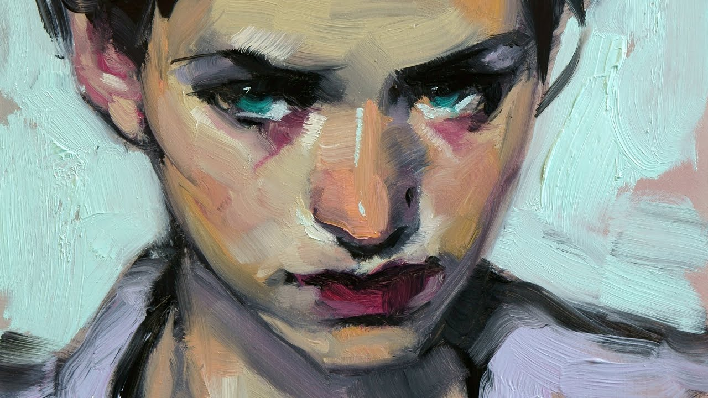
2.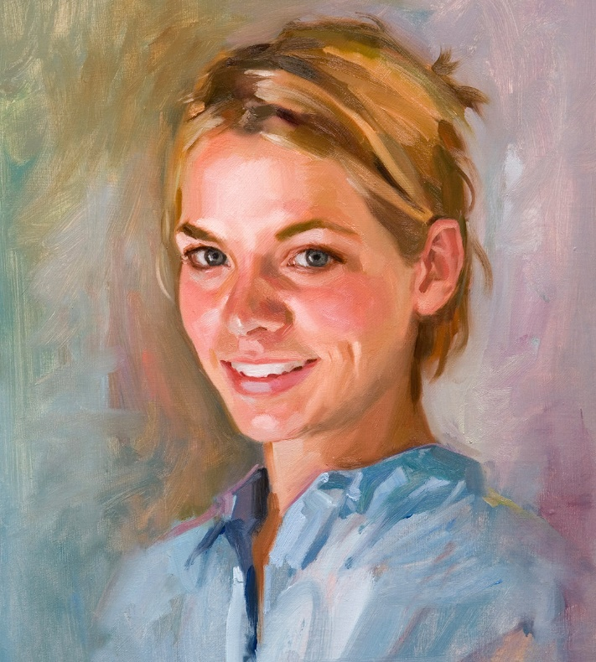 3.

