Date: March 1, 2018
In your journal record the following:
PAINTING 2 JOURNAL ENTRY #14:
Art Think: Look at the painting below. How do you think they did on their composition? Balance? Focal point?Eye path? Rule of thirds? Distracting elements?
Announcements/Reminders:
- Piece of a Masterpiece assignment is due TODAY!
- Journal check TODAY!
- March 8th is the last day to turn in any late work for this term.
Today’s Objective:
- Turn in Piece of a Masterpiece assignment
- Review
- Work on landscape
Homework: Get any late work done and turned in.

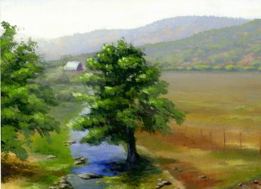
Balance? Focal point?Eye path? Rule of thirds? Distracting elements?

