February 18, 2022
PAINTING 2
Journal Entry #10
- ART THINK: REVIEW: See if you know the correct term for the parts of modeling below.
ANNOUNCEMENTS/REMINDERS:
- Journal check TODAY!
- Take or find a reference for your next painting (sky painting) by next Friday!
OBJECTIVES:
- Review
- Work on still life painting

Can you identify the parts of the modeling on this sphere?

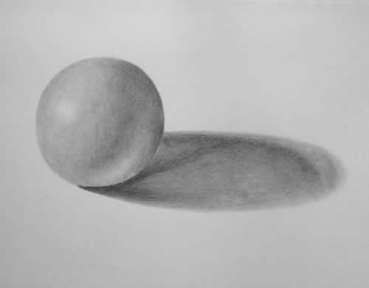
4.
1.
2.
3.

